Higher Nationals

Internal verification of assessment decisions – BTEC (RQF)

|  |  |  |  |  |  |  |
| --- | --- | --- | --- | --- | --- | --- |
| **INTERNAL VERIFICATION – ASSESSMENT DECISIONS** | | | | | | |
| **Programme title** | BTEC Higher National Diploma in Computing | | | | | |
| **Assessor** | Mr. Isura Kulathilaka | | **Internal Verifier** | Mr .Lakindu Premachandra | | |
| **Unit(s)** | **Unit 02: Networking** | | | | | |
| **Assignment title** | LAN Design & Implementation for SYNTAX SOLUTIONS | | | | | |
| **Student’s name** | Ranudi Gayathmie Kariyapperuma | | | | | |
| **List which assessment criteria the Assessor has awarded.** | **Pass** | | **Merit** | | **Distinction** | |
|  | |  | |  | |
| **INTERNAL VERIFIER CHECKLIST** | | | | | | |
| **Do the assessment criteria awarded match those shown in the assignment brief?** | | Y/N |  | | | |
| **Is the Pass/Merit/Distinction grade awarded justified by the assessor’s comments on the student work?** | | Y/N |  | | | |
| **Has the work been assessed accurately?** | | Y/N |  | | | |
| **Is the feedback to the student:**  Give details:   * Constructive? * Linked to relevant assessment criteria? * Identifying opportunities for improved performance? * Agreeing actions? | | Y/N  Y/N  Y/N  Y/N |  | | | |
| **Does the assessment decision need amending?** | | Y/N |  | | | |
| **Assessor signature** | | ranudigk@gmail.com | | **Date** | | 20.12.2022 |
| **Internal Verifier signature** | |  | | **Date** | |  |
| **Programme Leader signature** (if required) | |  | | **Date** | |  |

|  |  |  |  |
| --- | --- | --- | --- |
| **Confirm action completed** | | | |
| **Remedial action taken**  Give details: |  | | |
| **Assessor signature** |  | **Date** |  |
| **Internal Verifier signature** |  | **Date** |  |
| **Programme Leader signature** (if required) |  | **Date** |  |

Higher Nationals - Summative Assignment Feedback Form

|  |  |  |  |
| --- | --- | --- | --- |
| **Student Name/ID** | Ranudi Gayathmie Kariyapperuma - KIR/X-00104243 | | |
| **Unit Title** | **Unit 02: Networking** | | |
| **Assignment Number** | **1** | **Assessor** |  |
| **Submission Date** | 20/12/2022 | **Date Received 1st submission** | 20/12/2022 |
| **Re-submission Date** |  | **Date Received 2nd submission** |  |

|  |  |  |  |  |  |  |  |  |  |  |  |  |  |  |  |  |  |  |  |  |  |  |  |  |  |  |  |  |  |  |  |  |  |  |  |  |  |  |  |  |  |  |  |  |  |  |  |  |  |  |  |  |  |
| --- | --- | --- | --- | --- | --- | --- | --- | --- | --- | --- | --- | --- | --- | --- | --- | --- | --- | --- | --- | --- | --- | --- | --- | --- | --- | --- | --- | --- | --- | --- | --- | --- | --- | --- | --- | --- | --- | --- | --- | --- | --- | --- | --- | --- | --- | --- | --- | --- | --- | --- | --- | --- | --- |
| **Assessor Feedback:**   |  |  |  |  |  |  | | --- | --- | --- | --- | --- | --- | | **LO1 Examine networking principles and their protocols.** | | | | | | | **Pass, Merit & Distinction Descripts** | **P1** | **P2** | M1 |  |  |  | | **LO2 Explain networking devices and operations.** | | | | | | | **Pass, Merit & Distinction Descripts** | **P3** | **P4** | **M2** | **D1** |  |  | | **LO3 Design efficient networked systems.** | | | | | | | **Pass, Merit & Distinction Descripts** | **P5** | **P6** | **M3** | **D2** |  |  | | **LO4 Implement and diagnose networked systems.** | | | | | | | **Pass, Merit & Distinction Descripts** | **P7** | **P8** | **M4** | **D3** |  |  | |  | |

|  |  |  |
| --- | --- | --- |
| **Grade:** | **Assessor Signature:** | **Date:** |
| **Resubmission Feedback:** | | |
| **Grade:** | **Assessor Signature:** | **Date:** |
| **Internal Verifier’s Comments:** | | |
| **Signature & Date:** | | |

* Please note that grade decisions are provisional. They are only confirmed once internal and external moderation has taken place and grades decisions have been agreed at the assessment board.

**Assignment Feedback**

|  |  |  |  |
| --- | --- | --- | --- |
| **Formative Feedback: Assessor to Student** | | | |
| **Action Plan** | | | |
| **Summative feedback** | | | |
| **Feedback: Student to Assessor** | | | |
| **Assessor signature** |  | **Date** |  |
| **Student signature** | **ranudigk@gmail.com** | **Date** | 20.12.2022 |

**Pearson Higher Nationals in**

**Computing**

Unit 02: Networking

Assignment 01

**General Guidelines**

1. A Cover page or title page – You should always attach a title page to your assignment. Use previous page as your cover sheet and make sure all the details are accurately filled.
2. Attach this brief as the first section of your assignment.
3. All the assignments should be prepared using a word processing software.
4. All the assignments should be printed on A4 sized papers. Use single side printing.
5. Allow 1” for top, bottom , right margins and 1.25” for the left margin of each page.

**Word Processing Rules**

1. The font size should be **12** point and should be in the style of **Time New Roman**.
2. **Use 1.5 line spacing**. Left justify all paragraphs.
3. Ensure that all the headings are consistent in terms of the font size and font style.
4. Use **footer function in the word processor to insert Your Name, Subject, Assignment No, and Page Number on each pag**e. This is useful if individual sheets become detached for any reason.
5. Use word processing application spell check and grammar check function to help editing your assignment.

**Important Points:**

1. It is strictly prohibited to use textboxes to add texts in the assignments, except for the compulsory information. eg: Figures, tables of comparison etc. Adding text boxes in the body except for the before mentioned compulsory information will result in rejection of your work.
2. Avoid using page borders in your assignment body.
3. Carefully check the hand in date and the instructions given in the assignment. Late submissions will not be accepted.
4. Ensure that you give yourself enough time to complete the assignment by the due date.
5. Excuses of any nature will not be accepted for failure to hand in the work on time.
6. You must take responsibility for managing your own time effectively.
7. If you are unable to hand in your assignment on time and have valid reasons such as illness, you may apply (in writing) for an extension.
8. Failure to achieve at least PASS criteria will result in a REFERRAL grade .
9. Non-submission of work without valid reasons will lead to an automatic RE FERRAL. You will then be asked to complete an alternative assignment.
10. If you use other people’s work or ideas in your assignment, reference them properly using HARVARD referencing system to avoid plagiarism. You have to provide both in-text citation and a reference list.
11. If you are proven to be guilty of plagiarism or any academic misconduct, your grade could be reduced to A REFERRAL or at worst you could be expelled from the course

**Student Declaration**

I hereby, declare that I know what plagiarism entails, namely to use another’s work and to present it as my own without attributing the sources in the correct form. I further understand what it means to copy another’s work.

1. I know that plagiarism is a punishable offence because it constitutes theft.
2. I understand the plagiarism and copying policy of Pearson UK.
3. I know what the consequences will be if I plagiarise or copy another’s work in any of the assignments for this program.
4. I declare therefore that all work presented by me for every aspect of my program, will be my own, and where I have made use of another’s work, I will attribute the source in the correct way.
5. I acknowledge that the attachment of this document signed or not, constitutes a binding agreement between myself and Pearson, UK.
6. I understand that my assignment will not be considered as submitted if this document is not attached to the assignment.

**ranudigk@gmail.com**

**Student’s Signature: Date: 20.12.2022**

**(*Provide E-mail ID*) (*Provide Submission Date*)**

**Higher National Diploma in Computing**

Assignment Brief

|  |  |
| --- | --- |
| Student Name /ID Number | Ranudi Gayathmie Kariyapperuma KIR/X - 00104243 |
| **Unit Number and Title** | **Unit 2: Networking** |
| Academic Year | 2021/22 |
| Unit Tutor | Mr. Isura Kulathilake |
| **Assignment Title** | **LAN Design & Implementation for SYNTAX SOLUTIONS** |
| Issue Date | 30.10.2022 |
| Submission Date | 20.12.2022 |
| IV Name & Date |  |

|  |  |
| --- | --- |
| **Submission format** | |
| The submission should be in the form of an individual report written in a concise, formal business style using single spacing and font size 12. You are required to make use of headings, paragraphs and subsections as appropriate, and all work must be supported with research and referenced using Harvard referencing system. Please also provide an end list of references using the Harvard referencing system.  **The recommended word count is 3,000–3,500 words for the report excluding annexures, although you will not be penalised for exceeding the total word limit.** | |
|  | **Unit Learning Outcomes:** |
|  | **LO1** Examine networking principles and their protocols.  **LO2** Explain networking devices and operations.  **LO3** Design efficient networked systems.  **LO4** Implement and diagnose networked systems. |
|  | **Assignment Brief and Guidance:** |
| **Scenario**  **SYNTAX SOLUTIONS** is a privately owned, well-known Software company located in Colombo. The Management of **SYNTAX SOLUTIONS** has purchased a 3-story building in the heart of **Matara**. They are planning to make it one of the state-of-the-art companies in Matara with the latest facilities.  It is expected to have nearly **150 employees** in Matara branch.   |  |  | | --- | --- | | **Department** | **Number of Users** | | Customer Care | 10 | | Sales and Marketing | 20 | | Finance | 25 | | Legal | 5 | | HR | 10 | | Developers | 55 | | Network Team | 5 | | Server Room | Servers +ISP connections |   **Following requirements are given by the Management.**   * All the departments **must be separated** with **unique subnet** and should not communicate with each other **unless there is a special requirement**. * **192.168.10.0/24** is given and should be used for all the departments except the server room. IPs should assign **using DHCP**. * **ERP and CRM Systems** need to be implemented in Matara branch in local servers. * **Number of servers required for the Server room** need to be decided by the Network designer and should be assigned with **10.254.1.0/24** subnet. (Uses **static IPs**) * **High level of redundancy** is expected in network design to eliminate single point of failures and traffic bottle necks. * **Sales and Marketing** Team need to access Network resources **using WIFI** connectivity. * **Proper methods** for **networking monitoring** and **troubleshooting** need to be established. * All possible **network security** mechanisms should be implemented.   Assume you have been appointed as the new network consultant of **SYNTAX SOLUTIONS**. Prepare a network architectural design and implement it with your suggestions and recommendations to meet the company requirements.  ***(Note: Clearly state your assumptions. You are allowed to design the network according to your assumptions, but main requirements should not be violated)***  **Activity 01**   * + Discuss the benefits and constraints of different network system types that can be implemented in the Matara branch and the main IEEE Ethernet standards that can be used in above LAN and WLAN design.   + Discuss the importance and impact of network topologies and network protocol suites while comparing the main network topologies and network protocol suites that are used in network design using examples. Recommend suitable network topologies and network protocol suites for above scenario and justify your answer with valid points.   **Activity 02**   * Discuss the operating principles of network devices (Ex: Router, Switch, Etc.) and server types that can be used for above scenario while exploring different servers that are available in today’s market with their specifications. Recommend server/servers for the above scenario and justify your selection with valid points. * Discuss the inter-dependence of workstation hardware with networking software and provide examples for networking software that can be used in above network design.   **Activity 03**   * Prepare a written network design plan to meet the above mentioned user requirements including a blueprint drawn using a modeling tool. (Ex: Microsoft Visio, EdrawMax).   Support your answer by providing the VLAN and IP subnetting scheme for the above scenario and the list of devices, network components and software used to design the network for above scenario and while justifying your selections.   * Test and evaluate the proposed design to meet the requirements and analyse user feedback by using a User feedback form. * Install and configure Network services, devices and applications (Ex: VLAN,DHCP, DNS,Proxy, Web, Etc.) according to the proposed design to accomplish the user requirements and design a detailed Maintenance schedule for above Network.     \***Note: - Screen shots of Configuration scripts should be presented.**  **Activity 04**   * Implement a networked system based on your prepared design with valid evidences and recommend potential future enhancements for the networked system with valid justifications to your recommendations. Use critical reflection to critically evaluate the design, plan, configuration, and testing of your network while justifying with valid conclusions. * Develop test cases and conduct verification (Ex: Ping, extended ping, trace route, telnet, SSH, etc.) to test the above Network and analyse the test results against the expected results. | |
|  | |

**Grading Rubric**

|  |  |  |
| --- | --- | --- |
| **Grading Criteria** | **Achieved** | **Feedback** |
| **LO1 : Examine networking principles and their protocols.** | | |
| **P1**  Discuss the benefits and constraints of different network types and standards. | Achieve |  |
| **P2**  Explain the impact of network topology, communication, and bandwidth requirements. | Achieve |  |
| **M1**  Compare common networking principles and how protocols enable the effectiveness of networked systems. | Achieve |  |
| **LO2 : Explain** **networking devices and operations** | | |
| **P3**  Discuss the operating principles of networking devices and server types. | Achieve |  |
| **P4**  Discuss the inter-dependence of workstation hardware with relevant networking software. | Achieve |  |
| **M2**  Explore a range of server types and justify the selection of a server, considering a given scenario regarding cost and performance optimization. | Achieve |  |
| **LO 1 & LO2** | | |
| **D1** Critically evaluate the topology protocol selected for a given scenario to demonstrate the efficient utilization of a networking system. | Achieve |  |
| **LO3 : Design efficient networked systems** | | |
| **P5**  Design a networked system to meet a given specification. | Achieve |  |
| **P6**  Test and evaluate the design to meet the requirements and analyze user feedback. | Achieve |  |
| **M3**  Install and configure network services and applications on your choice. | Achieve |  |
| **D2**  Design a maintenance schedule to support the networked system. | Achieve |  |
| **LO4 : Implement and diagnose networked systems** | | |
| **P7**  Implement a networked system based on a prepared design. | Achieve |  |
| **P8**  Document and analyze test results against expected results. | Achieve |  |
| **M4**  Recommend potential enhancements for the networked systems. | Achieve |  |
| **D3**  Use critical reflection to evaluate own work and justify valid conclusions. | Achieve |  |

**ACKKNOWLEDGEMENT**

At last author would like to share the experience while doing the project. Author learns many new things about the networking topics. The best thing which author can share is that author developed more interest in this subject. This Project gave author a real sight into the Networking world.

A very special thanks to Mr Isuru Kulathilake who teach us this subject and Author thanks for who helped author to do this kind of project. Thank you!

Regards,

The author,

Ranudi Kariyapperuma.

**TABLE OF CONTENT**

LO1. Networking principles and their protocols. 23

P1. The benefits and constraints of different network types and standards. 23

1. Computer Networks 23

2. Benefits of Computer Networking 23

3. Network Architectures 25

3.1. Client – server architecture 25

3.1.1 Types of client server architecture 25

▪ 1-tier architecture 25

▪ 2-tier architecture 25

▪ 3-tier architecture 25

▪ N-architecture 25

3.2 Peer -to- peer architecture 27

3.2.1 Types of peer-to-peer Network 27

▪ Pure peer to peer network 27

▪ Unstructured peer to peer network 27

▪ Structured peer to peer network 27

▪ Hybrid peer to peer network 27

3.2.2. Advantages and Disadvantages of Peer-to-Peer Architecture 28

4. Types of Networks 29

1. Personal Area Network (PAN) 30

• Wired Personal area network 30

• Wireless Personal area network 30

2. Local Area Network (LAN) 31

2.1 The types of LAN networks 31

2.2 Key components of a LAN 31

3. Wide Area Network (WAN) 32

4. Wireless Local Area Network (WLAN) 32

5. Campus Area Network (CAN) 33

6. Metropolitan Area Network (MAN) 33

7. Storage Area Network (SAN) 34

8. System-Area Network (SAN) 34

9. Passive Optical Local Area Network (POLAN) 35

10. Enterprise Private Network (EPN) 35

11. Virtual Private Network (VPN) 36

12. Home Area Network (HAN) 36

4.1 Advantages and Disadvantages of Network Types. 37

6. Network Standards 41

5.1 Network Standards Organizations. 41

1) ISO (International organization for standardization) 41

2) ANSI (American National Standards Institutes) 42

3) IEEE (Institute of Electrical and Electronics Engineers) 42

4) INCTS (International Committee for Information Technology) 43

5) TIA (Telecommunications Industry Association) 43

P2. Explain the impact of network topology, communication, and bandwidth Requirements. 44

1. The impact of network topology. 44

1.1 Physical topology 44

1) Point to Point Topology 44

2) STAR TOPOLOGY 45

3) BUS TOPOLOGY 46

4) RING TOPOLOGY 47

4) TREE TOPOLOGY 48

4)MESH TOPOLOGY 49

5) Daisy Chain Topology 50

6) Hybrid Topology 50

7) Extended Star Topology 51

8) Dual Ring Topology 51

1.2 Logical Topology 52

1.3 The importance of Network topologies. 54

2. Communication and Bandwidth Requirements. 54

2.1. Bandwidth 54

2.2. The amount of bandwidth that needs for various types of services. 54

2.3 Importance of bandwidth 55

2.4 Bandwidth Measurements. 55

M1. Compare common networking principles and how protocols enable the effectiveness of networked systems. 56

1. Network Protocols 56

1.1. Types of Network Protocols. 56

• Transmission control protocol (TCP) 56

• Internet protocol (IP) 57

• User Datagram Protocol (UDP) 58

o Post office Protocol (POP) 59

o Simple Mail Transfer Protocol (SMTP) 59

o File Transfer Protocol (FTP) 60

o Hypertext Transfer Protocol Secure (HTTPS) 60

o Telnet 61

o Gopher 61

LO2: Networking Devices and Operations 62

P3: The operating principles of networking devices and server types. 62

1. Network Devices. 62

1.1 Networking Device Types 62

★ Repeater 62

★ Hub 62

★ Bridge 63

★ Switch 63

★ Router 64

★ Gateway 64

★ Brouter 65

★ NIC 65

2. Servers 66

2.1. Types of servers 66

• Web Server 66

• Proxy server 66

• Virtual server 66

• File transfer protocol server 66

• Application server 66

• File server 67

• Database server 67

• Mail server 67

• Print server 67

P4 : the inter-dependence of workstation hardware with relevant networking software. 68

1 . VMware Workstation 15.5 Installation 68

2. Window server 16 (Installation) 79

M2 : A range of server types and justify the selection of a server, considering a given scenario regarding cost and performance optimization. 85

1.Range of Server Types 85

2. Suitable server for the scenario. 86

D1: The topology and protocol selected for a given scenario 86

• Topology for given scenario. 86

• Protocol for the given scenario. 86

LO3: Design a efficient networked systems 87

P5: A networked system to meet a given specification 87

P6: Test and evaluate the design to meet the requirements and analyse user feedback 88

1. User Feedback Form of Syntax Solution Company. 88

1.1 User response Form of Syntax Solution Company. 91

2. Analaizing the user feedback form. 94

★ How the speed of the network service? 94

★ How the quality of the product? 95

★ How the user friendly of the product? 96

★ How the Security of the product? 97

★ How the organization of the Product? 98

M3: Install and configure network services and applications 99

1.Features of windows 11 vs windows 10 99

2. Configuring the Network System. 100

• Configuration Part of PC and servers 100

1. Custom care Department 100

2. Finance Department 101

3.Sales and Marketing Department 102

4.Legal Department 103

5.HR Department 104

6.Developers Department 105

7.Network Team Department 106

8.Server Room Department 107

3.Router Configuration 108

• Router 0 108

• Router 1 110

• Router 2 112

4.Switch Configuration. 116

D2: A maintenance schedule to support the networked system. 124

LO4: Implement and diagnose networked systems 125

P7: Implement a networked system based on a prepared design. 125

1. Network Design 125

2. IP Address Table 126

P8: Documenting and analysing test results against expected results. 127

M4: Potential enhancements for the networked systems. 131

1.User should configure the network daily. 131

2.Check for the viruses and system defectors. 131

3.Upgrade and Update Firmware and Software 131

4.Using Virtual Local Area Network 131

D3: Critical reflection to evaluate own work and justify valid conclusions. 132

• Conclusion 132

References 133

**Figures**

Figure 1 : Client server architecture( nimesha-dilini.medium.com) 26

Figure 2 : Peer-to-Peer Architecture (Designed by Author) 28

Figure 3 : Types of Networks (Inoformationq.com) 29

Figure 4 : Personal area network (Designed by Author) 30

Figure 5 : Local area network (Design by the author) 31

Figure 6 : Wide area Network (https://www.quora.com) 32

Figure 7 : Wireless Area Network (http://www.sunsystemonline.com) 32

Figure 8: Campus Area Network (community.fs.com) 33

Figure 9 : Metropolitan Area Network (www.sciencedirect.com) 33

Figure 10 : Storage Area Network (www.friktoria.com) 34

Figure 11 : System Area Network (www.networkstraining.com) 34

Figure 12 : Passive Optical Local Area Network (snabaynetworking.com) 35

Figure 13: Enterprise Private Network (www.itrelease.com) 35

Figure 14 : Virtual Private Network (ecomputernotes.com) 36

Figure 15: Home Area Network (www.geeksforgeeks.org) 36

Figure 16 : ISO (International organization for standardization)( www.legalraasta.com) 41

Figure 17 : ANSI (American National Standards Institutes) (http://www.legalraasta.com) 42

Figure 18 : IEEE (Institute of Electrical and Electronics Engineers) (http://www.spacebizguide.com) 42

Figure 19 : INCTS (Inter National Committee for Information Technology) 43

Figure 20 : TIA (Telecommunications Industry Association) 43

Figure 21: Point to Point topology (https://www.itrelease.com) 44

Figure 22 : Star Topology (Design by author) 45

Figure 23 : Bus topology (https://service.snom.com) 46

Figure 24 : Ring topology (https://www.javatpoint.com) 47

Figure 25 : Tree Topology ( https://www.itrelease.com) 48

Figure 26 : **mesh topology (itrelease.com)** 49

Figure 27 : Daisy Chain Topology (www.educba.com) 50

Figure 28 : Hybrid Topology (www.javatpoint.com) 50

Figure 29 : Extended Star Topology (www.researchgate.net) 51

Figure 30 : Dual Ring Topology ( https://www.pinterest.com) 51

Figure 31 : Bandwidth Measurements (networkustad.com) 55

Figure 32: Transmission Control Protocol (www.geeksforgeeks.org) 56

Figure 33 : Internet Protocol (forum.huawei.com) 57

Figure 34 : User Datagram Protocol (www.educba.com) 58

Figure 35 : Post Office Protocol (www.tech-faq.com) 59

Figure 36 : Simple Mail Transfer Protocol (www.educba.com) 59

Figure 37 : File Transfer Protocol (www.ipswitch.com) 60

Figure 38 : Hypertext Transfer Protocol secure (www.globalsign.com) 60

Figure 39 : Telnet (www.teachoo.com) 61

Figure 40 : Gopher Protocol (www.howtogeek.com) 61

Figure 41 : Repeater (https://ecomputerconcepts.com) 62

Figure 42 : Hub (https://www.javatpoint.com) 62

Figure 43 : Bridge (www.easytechjunkie.com) 63

Figure 44 : Switch ( infinity-cable-products.com) 63

Figure 45 : Router (www.javatpoint.com) 64

Figure 46 : Gateway (www.hitechwhizz.com) 64

Figure 47 : Brouter (www.learnabhi.com) 65

Figure 48 : NIC (www.elprocus.com) 65

Figure 49 : VMware 1 68

Figure 50 :VMware 2 69

Figure 51 :VMware 3 69

Figure 52 : VMware 4 69

Figure 53 : VMware 5 70

Figure 54 :VMware 6 70

Figure 55 : VMware 7 71

Figure 56 : VMware 8 71

Figure 57 : VMware 9 73

Figure 58: VMware 10 73

Figure 59 : VMware 11 74

Figure 60 :VMware 12 74

Figure 61 : VMware 13 75

Figure 62 :VMware 14 75

Figure 63 : VMware 15 76

Figure 64 : VMware 16 76

Figure 65 : VMware 17 77

Figure 66 : VMware 18 77

Figure 67 : VMware19 78

Figure 68 : VMware 20 78

Figure 69 : A networked system to meet a given specification 87

Figure 70 : User Feedback Form 1 88

Figure 71 : User Feedback Form 2 89

Figure 72 : User Feedback Form 3 90

Figure 73 : Custom care Department PC 100

Figure 74 : Finance Department PC 101

Figure 75 : Sales and Marketing Laptop 102

Figure 76 :Legal Department PC 103

Figure 77 : HR Department PC 104

Figure 78: Developers Department PC 105

Figure 79 : Network Team Department PC 106

Figure 80 : Server Room Department PC 107

Figure 81 : A maintenance schedule to support the networked system. 124

Figure 82 : networked system based on a prepared design 125

Figure 83 : IP Address Table 126

# LO1. Networking principles and their protocols.

## P1. The benefits and constraints of different network types and standards.

###### 1. Computer Networks

The modern corporate world is based on networks. The reason is that nowadays,

networks are utilized to access the internet and obtain information. A network is a

collection of connected computers that allows one computer to share its resources, data,

and programs with another computer. In networking, physical connections like fiber

optic cables and wireless technology are used to connect the devices.

### 

### 2. Benefits of Computer Networking

The Benefits of computer can divide into types. One is Advantage of computer network and other one is Disadvantage of Computer network.

|  |  |  |
| --- | --- | --- |
| Advantages | Disadvantages | |
| * Fast File Sharing | * Robustness | |
| The major advantage of computer network  is file sharing. All types of Data like audio, video, Text, and images can be shared easily. | The main server is totally dependent on the network connected systems. Because of that if the main server breaks down the system will cannot use anymore. Another thing is if there is a problem of linking device the whole system will be shut down. | |
| * Fast Resource Sharing | * Malware Attack | |
| Scanners, Printers, Network data and applications can be accessed by remote connection devices, using network connected devices. | A virus can spread quickly through computers in the network as a result of communication. There is high possibility that  Malware would spread to the other devices if one of them gets attacked. | |
| * Flexibility | * Maintenance | |
| It means in this present period people have requirements they search through the internet it means there is a flexibility in networking. | A computer Network needs a regular maintenance for work effectively. The issue is that basic knowledge is not enough for this. It needs complicated setups and complex modifications too. | |
| * Higher Connectivity | * Health Issues | |
| Can connect easily whenever user in another country or individually or public areas. For an example Internet is world wide web, WhatsApp, Facebook etc. | Today’s modern generation have many computer games to play in leisure time. These games are most play users as a stressbuster. But playing for long sessions can make a user addicted to it. Because of that it causes many health problems for both mentally and physically. | |
| * Collaboration | * Productivity | |
| Accessing a computer network enables communication specially in the business culture. Most of these types of working groups, arranging gatherings, or Receiving  individual response can be achieved without any difficult. | The fact that computer networking can decrease a efficiency of a company is biggest issue. Employees can use the internet for purposes other than office work when it is allowed. | |
|  | |

Table 1: Benefits of computer networking (Designed by author)

### 3. Network Architectures

A network functional and structural design called as a Network Architecture. This

Explains the concept controlling data transmit between network devices and

connected to one another. Client – server architecture and Peer -to-peer architecture

are the two main types of architectures.

#### 3.1. Client – server architecture

Client request data such as images, documents, videos etc. and the server

responds to that data called Client server architecture. It can be simple

responding of data or there can be logical manipulation on the data.

##### Types of client server architecture

###### 1-tier architecture

In this architecture the client server and database all reside on the same

Machine. As an example, the author install database and in author’s

system access it practices sql queries it is called 1 tier architecture.

###### 2-tier architecture

In 2 tier architecture presentation layer runs on client and data is stored

on a server. In this architecture a client request for data or resources to

server and server process that request. These both tiers are

communicated with internet or any other network. This structure is quite

easy to maintain and modify.

###### 3-tier architecture

This architecture has three layers. Namely Client, Application and

Data layer. The Client layer is the one that request the information. The

application layer. Acts as an interface between the Client and Data

layer. The data layer in the one the actually contains the required data.

This architecture contains on application layer between the user and the

dbms which is responsible for communicating the user’s request to the

dbms system and send the response from the dbms to the user.

###### N-architecture

This architecture also called as a multi-tier architecture. In this

Architecture entire presentations, application processing and

Data management function are confined from each other. This

Architecture complex , organized, Flexible, secure architecture.

**3.1.2. Advantages and Disadvantages of a Client server Architecture.**

|  |  |
| --- | --- |
| **Advantages** | **Disadvantages** |
| * **Scalability**   New clients and servers can add to it to make a extensive network.   * **Store Files**   Many files can be stored on a server and if any client needs them client can access those files from the server computer.   * **Expand Server**   If user want to store more files user can add more storage capacity to the server.   * **Dedicated Server**   It can be a file server, Print Server or Database Server.   * **Backup & Recovery**   Easy to backup data and recovering the data | * **Traffic issues**   Difficult to manage all request from the server because sometimes request are very high.   * **Very Expensive**   High processor and initial investments are need to a server computer but to buy a server is very high.   * **Server Dependency**   Always the client computer depends on the server computer. If the server fails the entire network will stop working.   * **Extra staff Needed**   A network Administrator is needed to look after the server and also needed more staff to manage the server. |

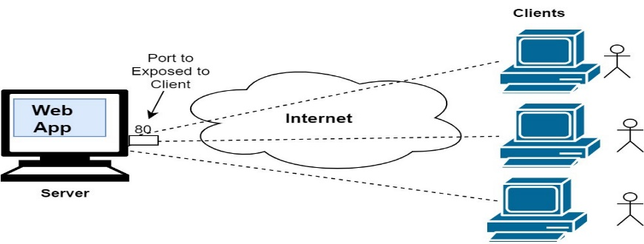

Figure : Client server architecture( nimesha-dilini.medium.com)

#### 3.2 Peer -to- peer architecture

In peer-to-peer architecture all computers are in computer network are connected

with every computer in the network. There is no central computer to access as a

sever. Every computer has an equal statue. Anybody can be a server in this

architecture.

##### 3.2.1 Types of peer-to-peer Network

###### Pure peer to peer network

It also uses a form as a fully peer to peer network. All peers in this

networks perform the exact similar function because there is no

central sever that serves to the network’s hub.

###### Unstructured peer to peer network

This type of network easy to connect various type of devices of a

Network however given the lack of organization it may be

Challenging for users to search for rare information.

###### Structured peer to peer network

It is not easy to build up this type of network even, so it provides

an excellent platform to discovering rare information.

###### Hybrid peer to peer network

As a result of a centralized powerful device the above network act

more like a client server network but these types of network are

usually peer to peer networks.

##### 3.2.2. Advantages and Disadvantages of Peer-to-Peer Architecture

|  |  |
| --- | --- |
| **Advantages** | **Disadvantages** |
| * **Cost**   Building and Maintaining this Network is overall cost is extremely inexpensive and the payment should also done only once.   * **Reliability**   In this Network the computers are not dependent on a central system. If a network fails one part, it doesn’t matter to the other computers.   * **Implementation**   It is easy to setup this network and no need additional knowledge for that only a hub or a switch needed for the connection.   * **Administration**   As each user does have the power to control the own system, there is no need for a specialized network administrator. User can choose any type of file that user want to share**.** | * **Decentralization**   This has no central server because of that the files are stored on individual machines. This  Makes it harder for the user to locate and find files.   * **Performance**   This is another issue facing in this network. Because each machine is used by one user and many users are used it then the performance will decrease, and it will decrease because more devices connect to the network.   * **Backup and Recovery**   Backup process is made way difficult since there is no central device to save the files on it because of that the files will save different locations then user can’t find it easily to backup.   * **Virus Attack**   To protect from viruses every computer must set own rules. There is no central device to monitor and control the spread of virus. Virus, Malware, Trojan can easily spread over the whole network. |

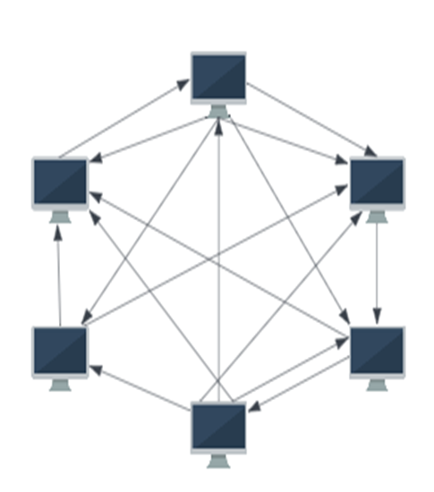

Figure : Peer-to-Peer Architecture (Designed by Author)

### 4. Types of Networks

Most users are known about 5 types of Networks but there are many kinds of network

Types. Namely the network types are,

**1. Personal Area Network (PAN)**

**2. Local Area Network (LAN)**

**3. Wide Area Network (WAN)**

**4. Wireless Local Area Network (WLAN)**

**5. Campus Area Network (CAN)**

**6. Metropolitan Area Network (MAN)**

**7. Storage Area Network (SAN)**

**8. System-Area Network (SAN)**

**9. Passive Optical Local Area Network (POLAN)**

**10. Enterprise Private Network (EPN)**

**11. Virtual Private Network (VPN)**

**12. Home Area Network (HAN)**

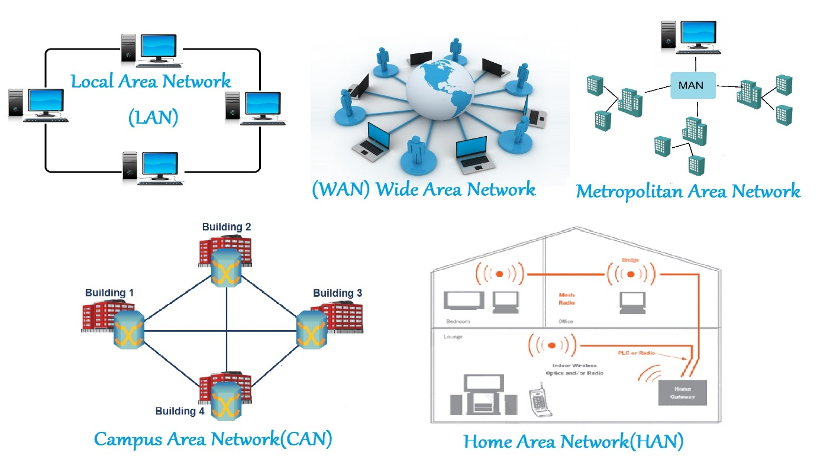

Figure : Types of Networks (Inoformationq.com)

##### 1. Personal Area Network (PAN)

* Personal area network (PAN) connects electro devices within the range of an individual person. The range of the personal are network is 10 meters to 30 feet. However this network is divided to types. The two types are called,

###### Wired Personal area network

In this network physical wires are used such as USB or

Fire wire to connect devices.

###### Wireless Personal area network

Wireless personal area network means that without a wired

Connection such as Bluetooth, Infrared, Ultra-wideband and

Wi-Fi connect the devices. In this type of the network

spread To 5 to 10 meters. Also Personal area network used

in several areas like Body area network,

Offline network and Small home office.

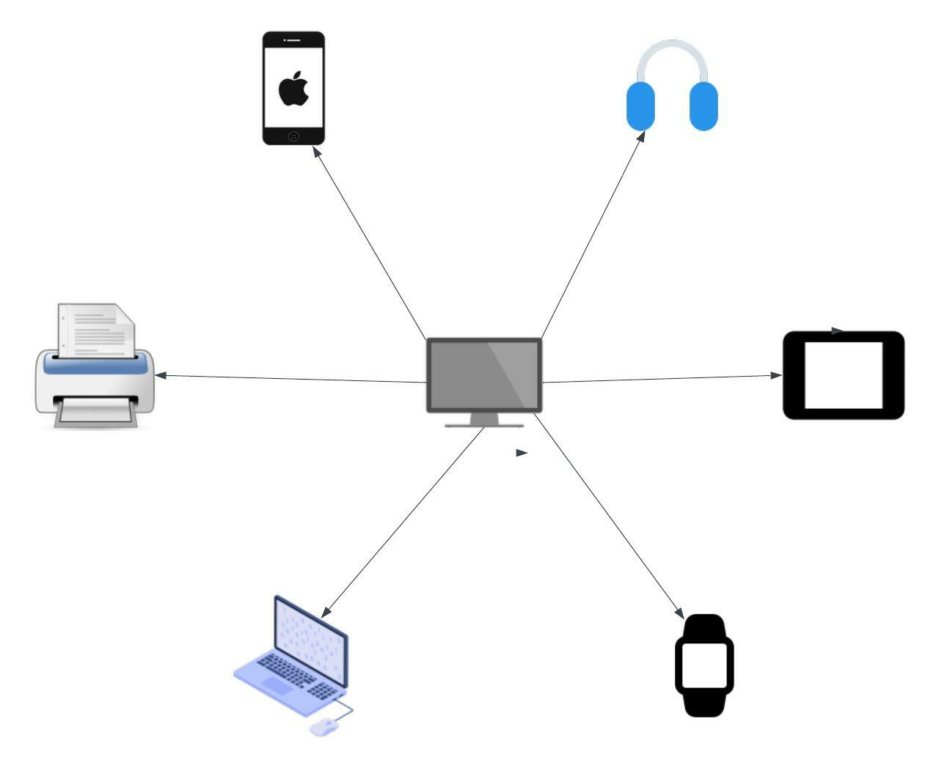

Figure : Personal area network (Designed by Author)

##### 2. Local Area Network (LAN)

Local area network is a network that connect devices with wired or wireless in a building,

Office, School etc. In the past mid of 1970s the first LAN design has been developed.

###### 2.1 The types of LAN networks

|  |  |  |
| --- | --- | --- |
| 1 | Client server LAN | A single server connects to multiple devices. |
| 2 | Peer to Peer LAN | No central device. All devices are inter connected to each other |
| 3 | Token ring LAN | Nodes are connect like a ring and all connected devices are assigned to token. |
| 4 | Token bus LAN | Nodes are connected like a tree branch and token share right side and left side. |
| 5 | Wired LAN | This is used electronic waves to transfer data through optical fiber. |
| 6 | Cloud managed LAN | This checks the network performance and security. |

###### 2.2 Key components of a LAN

###### 

* Modem
* Centralized server
* Network switches
* Wi-Fi router
* Public Internet
* Wired end user device
* Mobile end user device

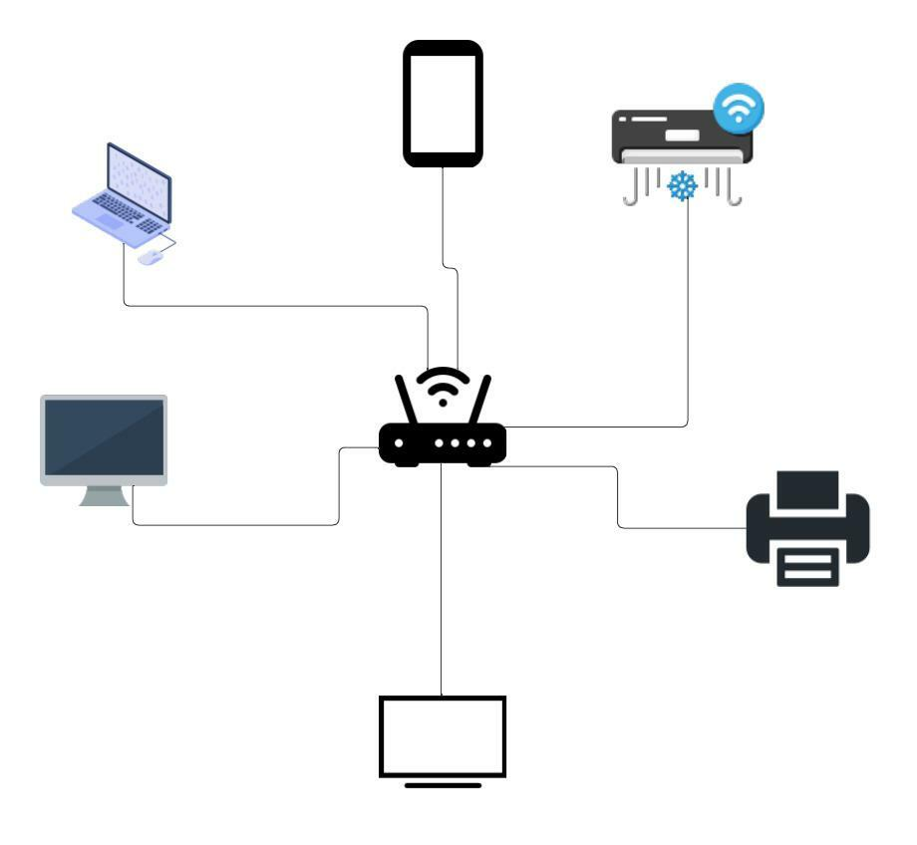

Figure : Local area network (Design by the author)

##### 3. Wide Area Network (WAN)

This is the Network that spread large geographical area. That means this spread through a

Country or worldwide. For an example Internet is wide area network. User can

Communicate or share anything wherever user in the world.

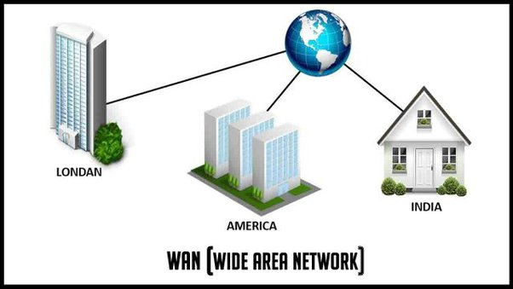

Figure : Wide area Network (https://www.quora.com)

##### 

##### 4. Wireless Local Area Network (WLAN)

This is also a type of a local area network. The difference is this LAN relates to a

Wireless communication. In WLAN at least one or more devices relate to

Wireless. For an example Wi-Fi router is WLAN.

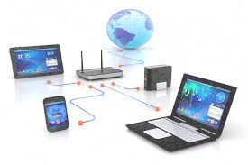

Figure : Wireless Area Network (http://www.sunsystemonline.com)

##### 5. Campus Area Network (CAN)

In Limit area that connected two or more LAN s are called Campus area network (CAN).

For an example in university there are several buildings that connected to each other

building in a university area.

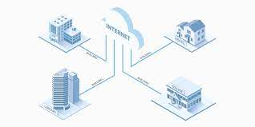

Figure : Campus Area Network (community.fs.com)

##### 6. Metropolitan Area Network (MAN)

#### 

This is bigger than the can network. This network that connected buildings only

inside a city. This commonly connected with a high-speed connection such as fiber

Optic cables. This can share data and resources quickly.

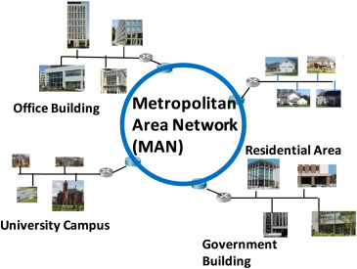

Figure : Metropolitan Area Network (www.sciencedirect.com)

##### Storage Area Network (SAN)

This is a high-speed network. This can store many data and can accessed to it. This

network is specialty designed to store the data. Storage area network has disk arrays,

switches and servers. SAN is used in LAN for avoid Network traffics. But this is not a

part of Local area network. Because of that SAN doesn’t get any distracters from

network traffics.

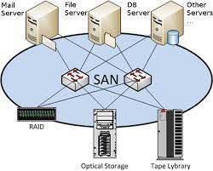

Figure : Storage Area Network (www.friktoria.com)

##### 8. System-Area Network (SAN)

A system area network is a group of devices that interconnected by a high speed

connection as an example clusters of client server computers. In this network there is

no specify person or year behind the invention.

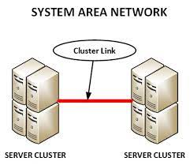

Figure : System Area Network (www.networkstraining.com)

##### 9. Passive Optical Local Area Network (POLAN)

This network is speed fiber from the data center to the desktop. In this network there

is called jeep on architecture. Jeep on architecture delivers converged voice, video

and data gigabit bandwidth layer to each computer. The information transported

security to make the passive MPO connectors are adding to save time and money.

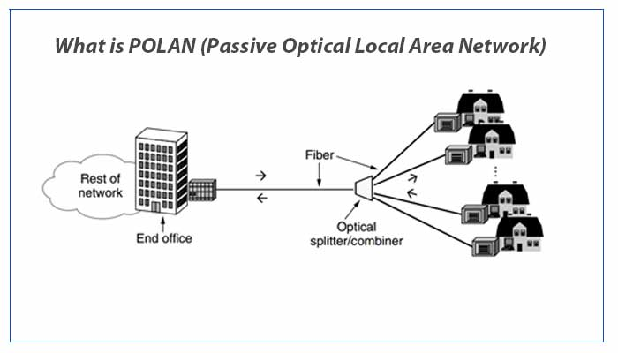

Figure : Passive Optical Local Area Network (snabaynetworking.com)

##### 10. Enterprise Private Network (EPN)

Enterprise network is built by business to communicate or interconnected with other

company sites. This network was built to share computer resources. This networking

was made in 1970s by AT&T. The purpose of this network is have high speed internet

and organized data sharing.

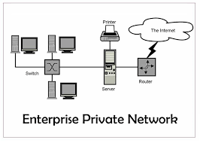

Figure : Enterprise Private Network (www.itrelease.com)

##### 11. Virtual Private Network (VPN)

Virtual private network is a protect network connection when user using public

Networks. This makes difficult for stealers to steal data prom the user. Also, There

are different kinds of VPNs. Such as,

* SSL VPN
* Site to Site VPN
* Client to Server VPN

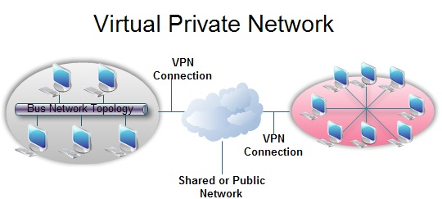

Figure : Virtual Private Network (ecomputernotes.com)

##### 12. Home Area Network (HAN)

This Network connect with all digital devices such as laptops, computers, smart

phones in a home. Home Area Network can be wired or wireless and it is a type

of a Local Area Network.

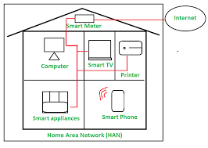

Figure : Home Area Network (www.geeksforgeeks.org)

#### 4.1 Advantages and Disadvantages of Network Types.

|  |  |  |
| --- | --- | --- |
| **Network Type** | **Advantages** | **Disadvantages** |
| **Personal Area Network**  **(PAN)** | * Can conserve space. | * This network can operate in less range of areas. |
| * Simple to use. | * Slow data sharing. |
| * It is trustworthy. | * Health related problems. |
| * Cost is inexpensive | * Data can be lost because of interfere with radio signals |
| * It is protected. | * Infrared signals give service only in a straight line. |
| **Local Area Network**  **(LAN)** | * Easily can share devices. | * It is difficult to install, and it is expensive. |
| * With a fast performance easily share data. | * A problem with information security. |
| * Cheaper Costs. | * Major restriction due to distance |
| * User can save their work centrally on the networks file server. | * If the server fails all devices could be adversely affected. |
| **Wide Area Network**  **(WAN)** | * High Efficiency | * This is a complicated and complex network. |
| * Cover a large network. | * Hard to maintain the network. |
| * Communication is easy. | * Problems of security. |
| * Spread information over a wide area. | * This is a public network and user privacy will be enhanced significantly. |
| * Any other network user can receive messages quickly. | * Need of high performance. |
| **Wireless Local Area Network (WLAN)** | * It's a trustworthy method of communicating. | * WLAN calls for a license. |
| * Workstations are simpler to feature or remove. | * WLAN uses frequency, which could cause interference with other frequency-using devices. |
| * Workstations are simpler to feature or remove. | * It's a limited area to hide. |
| * The sunshine of sight is not necessary for reproduction. | * Data transfer rate decreases as there are more connected devices. |
| * Workstations are simpler to feature or delete. | * Chances of errors are high. |
| **Campus Area Network (CAN)** | * Sharing Data is Simple | * It can support up to a 40-meter length |
| * Connect Wirelessly | * Unwanted interactions between all nodes in a CAN network appear. |
| * File Transfers Happen Quickly | * High Cost for software development and maintenance |
| * Economical | * Limited number of nodes |
| * Internet connection shared | * Node interactions that are undesirable |
| **Metropolitan Area Network (MAN)** | * High speed than WAN | * Hackers target |
| * MAN has a higher level of security than WAN. | * To set up, technical personnel are needed. |
| * A MAN usually encompasses several blocks of a city or an entire city | * When compared to LAN, the data rate is low. |
| * A MAN usually encompasses several blocks of a city or an entire city | * More cable requires for a MAN connection from one place to another |
| **Storage Area Network (SAN)** | * Speedy | * Expensive |
| * Flexible | * Complex |
| * Speedy, Flexible | * Privacy |
| * Reduced hard disk usage | * Not Good for High Traffic |
| * Effective Data Security | * Maintenance |
| **Passive Optical Local Area Network (POLAN)** | * High rate. | * installing problems |
| * a greater distance | * problem evolve |
| * Less cable is required. | * Transfer problem |
| * both upstream and downstream, high | * The difficulty at the corporate level |
| * Numerous connections Uses Less Energy | * Detection of Individual Bandwidth Splitter Failures |
| **Enterprise Private Network (EPN)** | * Secure than other public networks of its kind. | * unavailable with certainty |
| * This network can swiftly expand without incurring significant costs. | * unpredictable behavior |
| * It is best for business users | * a lack of fine-grained security |
| * Through EPN, several offices are centralized. | * Scalability is hampered by the complexity |
| * EPN is cost-effective for big companies | * Not intended for ongoing use. Never was an enterprise-wide WAN connection the use case for remote access VPNs. |
| **Virtual Private Network (VPN)** | * Safe Connection for Distance Work | * Missing Connections |
| * Cost-Effective Security | * Not All Countries Allow the Use of VPNs |
| * Ensure Safety by Remaining   anonymous | * High-quality VPNs Are Expensive |
| * VPNs Improve Online Gaming | * Choosing the Wrong VPN Could Endanger Your Privacy |
| * VPNs Can Get Around Firewalls | * Not All Devices Support VPNs Natively |
| **Home Area Network (HAN)** | * Multiuser | * Slow Connectivity |
| * Security | * Requires High Security |
| * sharing of resources | * Expensive |
| * Accessibility | * Wi-Fi - microwaves |
| * Maintenance | * Lack of WIFI password |

### Network Standards

A network that begins designed from the documents than contain technical and

physical specifications are called Network Standards.

Types of Networks Standard

De Facto Standards De Jure Standards

This standard is not followed any

Formal plan or a not recognized

By organization.

* Ex - Apple company established their own rules on their products.
* These standards are recognized by the organization.
* Ex – SMTP

TCP

IP

UDP

#### 5.1 Network Standards Organizations.

##### ISO (International organization for standardization)

ISO stand for Internet society. Iso founded in 1992 and handles Internet

standards Education and development. The mission of ISO is making

open Internet development and help to raise the organization that use

Internet and individuals worldwide.

Figure : ISO (International organization for standardization)( www.legalraasta.com)

##### ANSI (American National Standards Institutes)

ANSI is a private nonprofit organization. ANSI was founded in 1918.

ANSI represents and serves for standards, developers, government,

Manufacturing, Academia etc. For an example SQL is an ANSI because

SQL follow the rule and regulations of ANSI.

Figure : ANSI (American National Standards Institutes) (http://www.legalraasta.com)

##### IEEE (Institute of Electrical and Electronics Engineers)

This is worldwide educational and professional organization. Nowadays

IEEE was spread more than 160 countries. IEEE developers worldwide

In a broad range of industries such as power and energy, health care,

Learning technology etc.

Figure : IEEE (Institute of Electrical and Electronics Engineers) (http://www.spacebizguide.com)

##### INCTS (International Committee for Information Technology)

INCTS stands for manage and create standards in Information

And Communication technologies. INCTS was founded in 1980.

This develops standards and products in processing, transfer, data

Storage etc.

Figure : INCTS (Inter National Committee for Information Technology)

(https://data:image)

##### TIA (Telecommunications Industry Association)

TIA represent the interest of worldwide information and

communication technology industry. The company that involves

such as telecommunicating broadband, mobile, wireless etc.

Figure : TIA (Telecommunications Industry Association)

## P2. Explain the impact of network topology, communication, and bandwidth Requirements.

### 1. The impact of network topology.

Topology means a Greek word. “Topo” means place and “logy” means study. However, Network topology means the arrangement of a communication network**.** Network topology can divide into two parts that are called,

* + - 1. Physical topology
      2. Logical topology

#### Physical topology

##### 1) Point to Point Topology

This topology is the simplest topology in the network topology. Point to Point topology connects two nodes directly together with a common link. In Point to Point Topology Transfer data can be multiple ways like simplex, full duplex and half duplex**.**

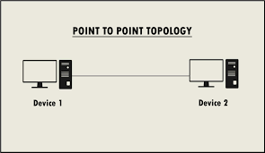

Figure : Point to Point topology (<https://www.itrelease.com>)

|  |  |
| --- | --- |
| **ADVANTAGE** | **DISADVANTAGE** |
| * Node can be replaced quickly | * **This topology use for small areas** |
| * Easy to handle and maintain | * **The entire network is depends on the cable or a single link.** |
| * Each point to point can use different networks | * **There is a only serever stay if it fails the system fails.** |
| * Security |
| * Low cost |

##### 2) STAR TOPOLOGY

This Topology consists of a central node to which all other nodes are connected by a single path. It is the topology used in most existing information networks involving data processing or voice communications.

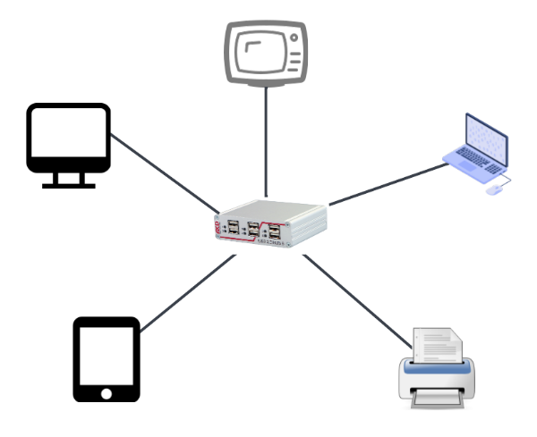

Figure : Star Topology (Design by author)

|  |  |
| --- | --- |
| **ADVANTAGES** | **DISADVANTAGES** |
| * Ease of Service | * Long Cable length |
| * One Device per Connection | * Difficult to Expand |
| * Centralized Control | * Central node Dependency |
| * Simple Access Protocols | * Extra hardware is required |

##### 3) BUS TOPOLOGY

The linear topology is another well-liked one for data networks. The different nodes are connected to a single length of the transmission medium, which is often a coaxial wire. The topology is utilized in conventional data communication networks, where the host is located at one end of the bus and connects with numerous terminals attached along its length. Any station's transmission can be picked up by another station because it travels the entire length of the bus in both directions. At each end of the bus are terminators that take in the signal and remove it from the bus. Data is transferred in discrete units called packets. In addition to a header specifying the destination address, each packet also contains some data bits. When a station wants to deliver data, it does so in packets.

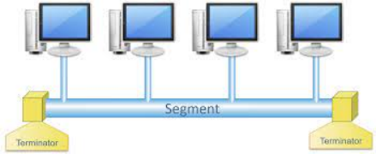

Figure : Bus topology (https://service.snom.com)

|  |  |
| --- | --- |
| **ADVANTAGES** | **DISADVANTAGES** |
| * Short Cable Length | * Fault Diagnosis is difficult |
| * Resilient Architecture | * Fault isolation is difficult |
| * Easy to Extend | * Repeater configuration |
| * Easy to Connect or remove a device. | * Nodes must be intelligent |
| * Easy to understand the topology. | * Packet loss is high |

##### 4) RING TOPOLOGY

Each node in this topology is linked to two and only two surrounding nodes. One of the nearby nodes sends data to the other, which is then accepted. As a result, information only moves from node to node around the ring in one way. It returns to the sender node, which removes it, after traveling through each node. It's crucial to remember that information "passes through" each node rather than "travels past" it. Accordingly, the signal might be enhanced before being "replayed" on the external channel.

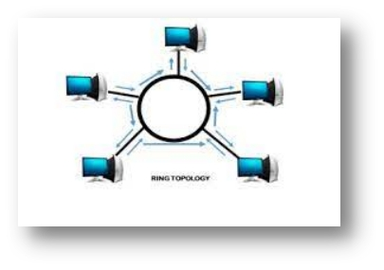

Figure : Ring topology (https://www.javatpoint.com)

|  |  |
| --- | --- |
| **ADVANTAGES** | **DISADVANTAGES** |
| * Short Cable Length | * Node Failure Causes Network Failure |
| * No Wiring closet space Required | * Difficult to diagnose Faults |
| * Suitable For Optical Fibers | * Network Reconfiguration is difficult |
| * Easy to Manage | * Not Scalable |
| * Data transferring is Speedy | * Depending on one cable. |
| * Low interaction | * This is Expensive |

##### 4) TREE TOPOLOGY

A unique kind of structure called a tree topology has numerous connected parts arranged like the branches of a tree. For instance, tree topologies are widely used to arrange the data in a database or the machines in a business network.

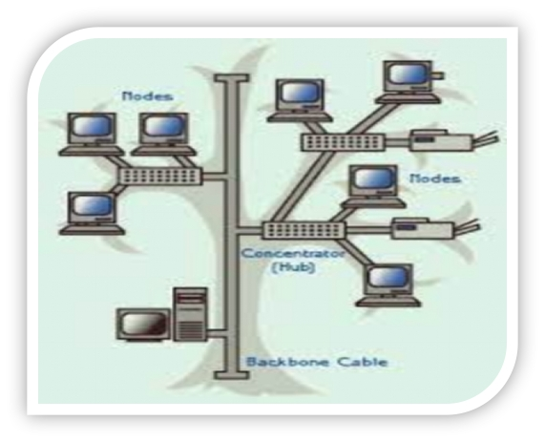

Figure : Tree Topology ( https://www.itrelease.com)

|  |  |
| --- | --- |
| **ADVANTAGES** | **DISADVANTAGES** |
| Reliable | Cost |
| Highly Secure | Maintenance |
| Easy Expansion | Security |

##### 4)MESH TOPOLOGY

A network configuration known as a mesh topology has devices such as computers and routers connected. Most transmissions can be spread with this architecture even if one of the connections fails. It is a topology that wireless networks frequently employ. Here is a picture of a straightforward computer configuration on a mesh network.

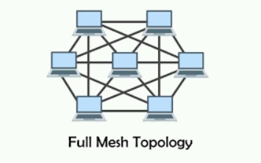

Figure : **mesh topology** [**(itrelease.com**](http://itrelease.com)**)**

|  |  |
| --- | --- |
| ADVANTAGES | DISVANTAGES |
| Easy To Add New Devices | Difficult |
| Almost Impossible to take down | Complex Structure |
| Scalability Is Simple | Costly Compared to Others |
|  |  |
|  |  |
|  |  |
|  |  |

##### 5) Daisy Chain Topology

This is a network that can connect one computer to another computer without bothering about another devices. This network is also simple network, and it can add more ethernet devices to the network. This type of network can be linear or ring topology type.

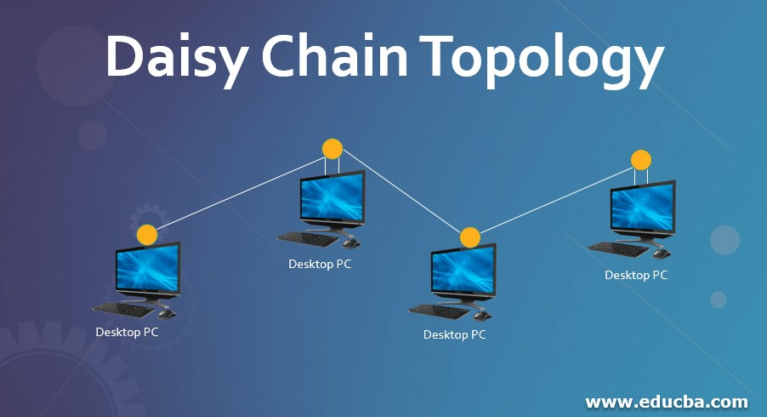

Figure : Daisy Chain Topology (www.educba.com)

##### 6) Hybrid Topology

The meaning of hybrid topology is that can design a network structure with 2 or more topogies like star, bus, ring, mesh, tree like wise. The biggest example for hybrid topology is the Internet. There are also have two types for hybrid topologies .there are ,

* Star – ring hybrid topology
* Star – bus hybrid topology

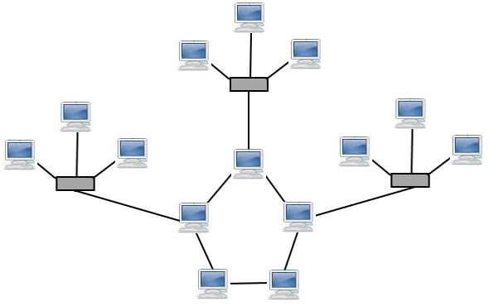

Figure : Hybrid Topology (www.javatpoint.com)

##### 7) Extended Star Topology

In this Network there are multiple switches and hubs and all connected to a one main hub. This is a large network. This is like a crystal type topology.

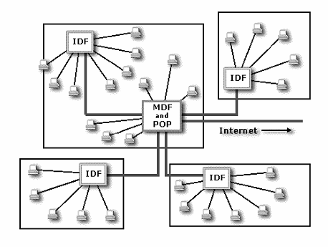

Figure : Extended Star Topology (www.researchgate.net)

##### 8) Dual Ring Topology

This topology uses two rings for the Network and the two rings are called as one is a primary ring and other one is secondary ring. Incase if the primary ring has a failure, then the secondary ring will handle the network.

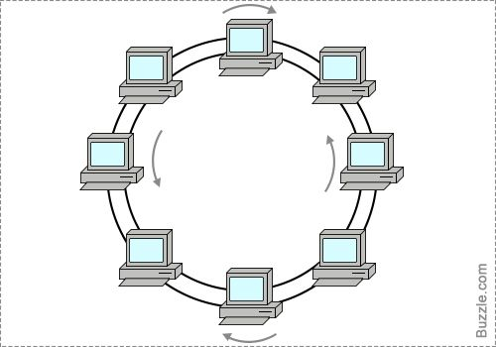

Figure : Dual Ring Topology ( https://www.pinterest.com)

#### 1.2 Logical Topology

This topology shows how data will pass from one device to another device through network. As examples,

* Ethernet
* Giga Ethernet
* Fast Ethernet

|  |  |
| --- | --- |
| **LOGICAL TOPOLOGY** | **EXPLANATION** |
| **ETHERNET** | * This was made in 80’s to connect devices in a home or a building it called as LAN also. * This can connect multiple devices and store and share information for others. * Ethernet is a wired system that firstly use with coaxial cable and now it is developed and using twisted pair copper wiring and fibre optics wiring. * Twisted pair wiring was invented in 1881 by Alexander Graham Bell. * 1983 – Ethernet was standardized into the IEEE802.3 Standard by Electrical and Electronic Engineers. * Ethernet Divided into two parts. That are called, * Physical Layer * Data Link Layer * These two layers are the first and second layer of the OSI (Open system Interconnect) Model. |

|  |  |
| --- | --- |
| **GIGA ETHERENET** | * Dr Robert Metcalf was the founder of the gigabit ethernet then intel, digital and xerox introduce the gigabit ethernet in 1970s. * The IEEE 802.3 Committee approved the first gigabit ethernet in 1988. * One gigabit per second is the maximum allowable data rate that giga ethernet can allow. * Gigabit ethernet works using regular Ethernet cable like CAT5E AND CAT6 cabling stands but if there is a long distance then use the fibre optic cables and special cables. |
| **FAST ETHERNET** | * Fast Ethernet was created in 1995 under IEEE 802.3U standard. * I local area networks fast ethernet carry data traffic at 100mega bit per second. * This has cable transmission and network protocols. * User can use fast ethernet and twisted pair cables. * Fast ethernet has various types. That are: - * 100 Base TX * 100 Base T2 * 100 Base T4 * 100 Base T1 |

#### 1.3 The importance of Network topologies.

1. User can see how the network functions through a network topology
2. IT administrator can understand how the network work when user make a network topology.
3. User can solve problems easily when user make a network topology.
4. Explain how the network devices and applications work in a network through a topology.
5. Gives a distributed network to been shown geographically.

### 2. Communication and Bandwidth Requirements.

#### 2.1. Bandwidth

* In each time period over a network connection that transferring data through a wired or wireless communication of a maximum capacity when it is measuring

It is called as Bandwidth.

* Bandwidth can represent in a number of bits, kilobits, megabits or gigabits that transfer in 1 second.
* When a data connection has more bandwidth more data will send and receive at one at a time.

#### 2.2. The amount of bandwidth that needs for various types of services.

* **25 Mbps -** 4k ultra–HD Video streaming with Netflix or YouTube.
* **5Mbps -** HD 1080p video streaming Netflix or YouTube
* **3Mbps -** 720p video calling like zoom meeting
* **1.5Mbps -** Broadcast
* **0.5Mbps** - Live streaming such as websites
* **150kbps** - Screen sharing
* **80kbps -** VOIP Calling

#### 2.3 Importance of bandwidth

* For emails small amount of bandwidth is enough because of that little amount of data been transmitted
* Video Conferencing needs lots of bandwidth because lots of data transmitted.
* Bandwidth isn’t free.
* Bandwidth is flint.

#### 2.4 Bandwidth Measurements.

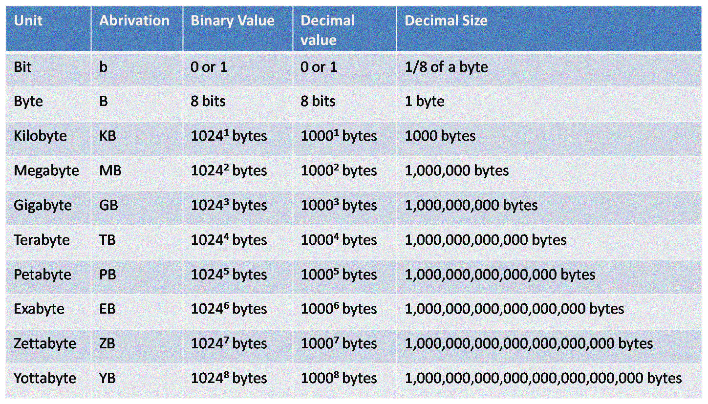

Figure : Bandwidth Measurements (networkustad.com)

## M1. Compare common networking principles and how protocols enable the effectiveness of networked systems.

### 1. Network Protocols

Network protocol known as set of rules for communicating between two

computers. For an example a person that speaking Japanese and a person that

speaking Sinhala, they can’t communicate each other because they have different

languages but they have a solution they can speak English to communicate. That’s

how two computers also communicate each other they use a set of rules to

understand the language that communicate.

#### 1.1. Types of Network Protocols.

##### Transmission control protocol (TCP)

* This is a protocol that use in network communicating by data transferring like internet.
* This protocol is placed between application layer and the network layer.
* This protocol is a most important protocol.
* Transmission Control Protocol has a end to end communication.
* This protocol organized the data and then client and server can easily transfer the data.
* This protocol can perform the roll of sender and a receiver because this protocol is a full duplex server.
* TCP has an error controller to handle the errors.

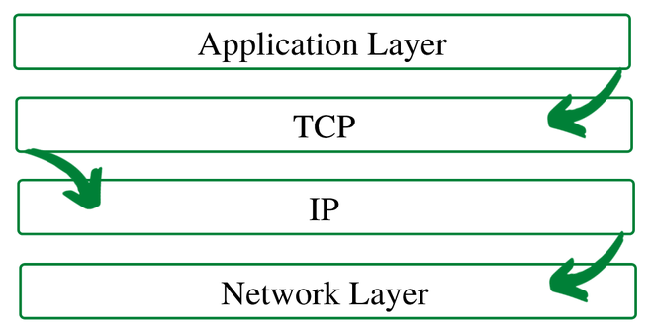

Figure : Transmission Control Protocol (www.geeksforgeeks.org)

##### Internet protocol (IP)

* Internet protocol is a protocol that data sent one computer to another computer through internet.
* The first version of Ip protocol is version 4 it is also known as IPv4 and second version is 6 it is known as IPv6 this was clarified by IETF in 1998.
* The difference between IPv4 and IPv6 is Ipv4 uses 32 bites addressing and IPv6 uses 128 bites for addressing.
* Internet protocol characterize 2 things. That are known as,

* Format of IP Packet

* Header and payload components are added to IP packet before it sent through network.
* Ip header has lots of information about Ip packet such as
* Header length
* Packet length
* Source Ip address
* Destination Ip address
* IP addressing system
* Ip address System also categorize into two section that are,
* Public address
* Public addresses are used in wide area Networks.
* Private address
* Private addresses are used in Personal area Network.

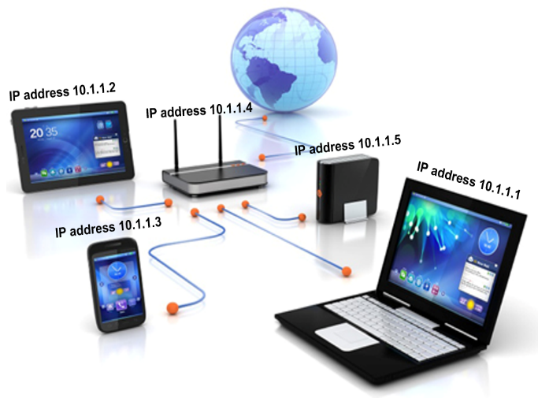

Figure : Internet Protocol (forum.huawei.com)

##### User Datagram Protocol (UDP)

* User Datagram Protocol is used for Time sensitive transmission like playback etc... through internet.
* Tis protocol was made in 1980 by David. P. Reed.
* The Benefits of UDP are,
* UDP has a useful speed.
* UDP is suitable for Broadcasting
* There is error detection also.
* The packet transmission needs less time to transfer.
* The UDP Header structure rows are,
* Source port
* Destination port
* Length
* Checksum

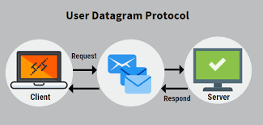

Figure : User Datagram Protocol (www.educba.com)

##### Post office Protocol (POP)

* This is an internet protocol that recover emails from an isolate mail server.
* This is also a application layer of OSI model this provides end users to get emails easily.
* This protocol was 1984 by the internet engineering task force.
* In 1985 POP2 version has introduce and the POP3 version was introduce in 1988.

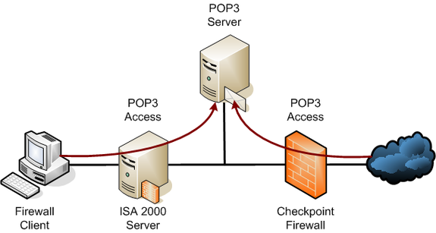

Figure : Post Office Protocol (www.tech-faq.com)

##### Simple Mail Transfer Protocol (SMTP)

* Simple Mail Transfer Protocol is set of communication instruction that allows to a software to transfer electronic mail through internet.
* This protocol used for sending messages through email address.
* When user send message to another person through email it is okay to

Share text, images, videos etc...

* In this protocol a one message can send to a one person or many.
* This protocol has two types that are,
* End to End Method
* Store and Forward Method

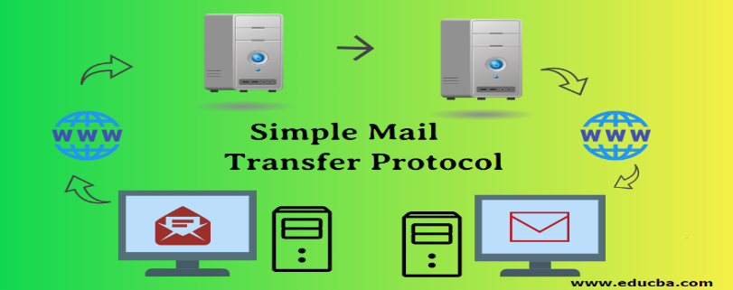

Figure : Simple Mail Transfer Protocol (www.educba.com)

##### File Transfer Protocol (FTP)

* This Protocol is used for when transfer files through TCP or IP Model.
* Businesspeople use file transfer protocol is use for share files between computers but websites use file protocol for uploading and downloading of files in website servers.
* The Types of File Transfer Protocol
* Ftp Plain
* Ftps
* Ftpes

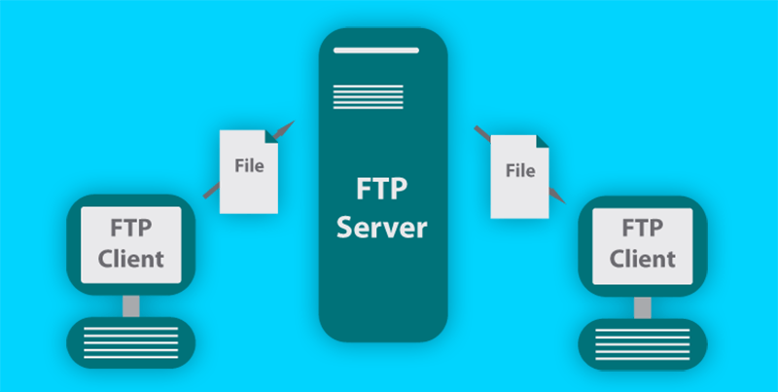

Figure : File Transfer Protocol (www.ipswitch.com)

##### Hypertext Transfer Protocol Secure (HTTPS)

* This protocol is the secure version of Http.
* Https are mostly used for online transactions such as online baking and online shopping etc…
* Https uses 443 no port for Data communication.



Figure : Hypertext Transfer Protocol secure (www.globalsign.com)

##### Telnet

* Telnet is a protocol that use computer to access virtually.
* This use for communicating with a remote device.

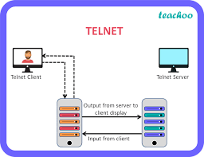

Figure : Telnet (www.teachoo.com)

##### Gopher

* This is an application layer that can pull out and see a web document that store in a remote web server.
* Gopher was founded on 1991 this was discovered by university of Minnesota.
* Gopher is designed for share to see the documents on internet.



Figure : Gopher Protocol (www.howtogeek.com)

# LO2: Networking Devices and Operations

## P3: The operating principles of networking devices and server types.

### 1. Network Devices.

Network devices, also known as networking hardware, are physical devices that

allow hardware on a computer network to communicate and interact with one

another.

(GeeksforGeeks, 2022)

#### 1.1 Networking Device Types

##### Repeater

Before a network signal becomes weak this these devices will help to regenerate the signals in same network. This device controls the physical layer. (GeeksforGeeks, 2022)

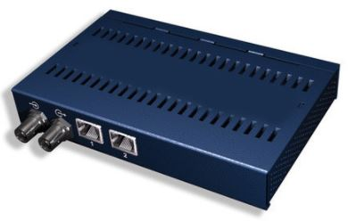

Figure : Repeater (https://ecomputerconcepts.com)

##### Hub

Hub Is use for connecting branches, wires of a topology. Like star topology. There are 3 types of hubs that are,

* Active Hub
* Passive Hub
* Intelligent Hub (GeeksforGeeks, 2022)

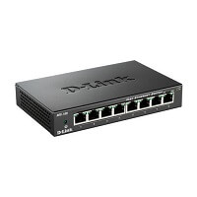

Figure : Hub (https://www.javatpoint.com)

##### Bridge

This network device connects two or more network portions together. Bridge is like a Hub because there are connect Lan components with protocols that identified. Bridges also work at physical and data link in OSI model. There is main two types of Bridges that are known as, (GeeksforGeeks, 2022)

* Transparent Bridge
* Source Routing Bridge

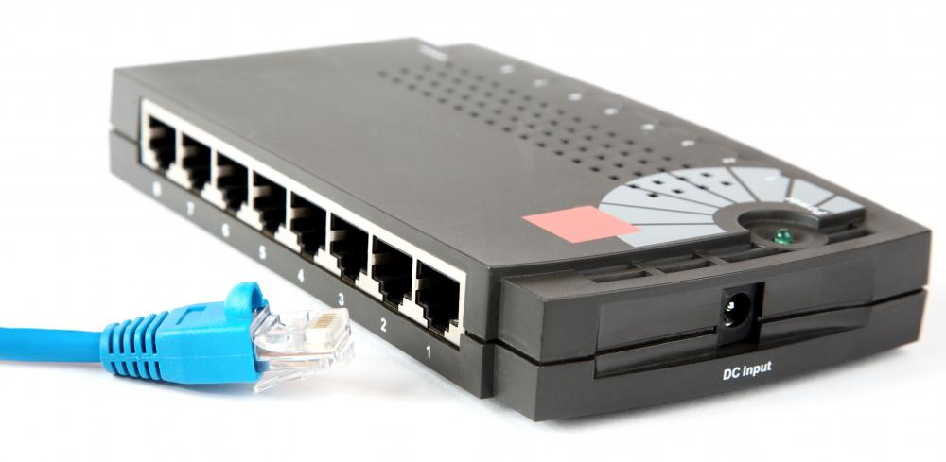

Figure : Bridge (www.easytechjunkie.com)

##### Switch

A switch will check errors before forwarding the data in network. This

device is a data link layer device. (GeeksforGeeks, 2022)

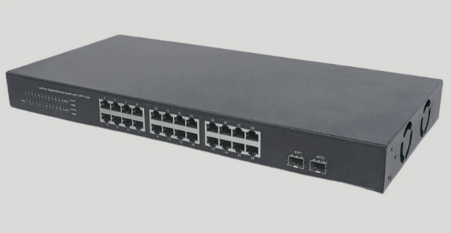

Figure : Switch ( infinity-cable-products.com)

##### Router

Router is transfer data packets t others on a Ip address. This device is a

layer device. Routers connect WAN and PAN usually.

(GeeksforGeeks, 2022)

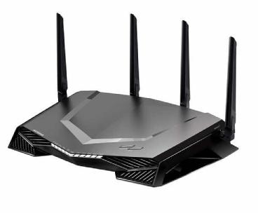

Figure : Router (www.javatpoint.com)

##### Gateway

Gateway is also known as protocol converter. This are Network layer

devices. This device works like a ambassador that get data

from Network Devices or system. (GeeksforGeeks, 2022)

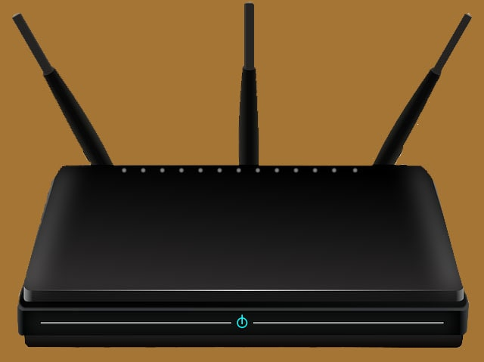

Figure : Gateway (www.hitechwhizz.com)

##### Brouter

This device is a multiple device that use bridge and router. This device can work as a data link Layer or network layer. This works like transfer data packets through network and filter Lan traffic. (GeeksforGeeks, 2022)

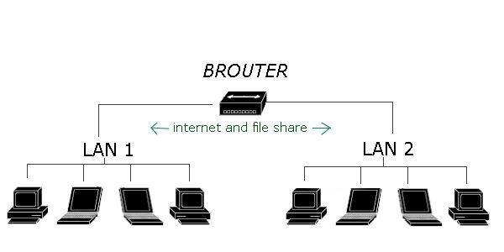

Figure : Brouter (www.learnabhi.com)

##### NIC

NIC means Network Interface Card.This is a Wi-Fi card that use to a device for WIFI. NIC has 2 layers that are known as physical and data link layer of a network system. (GeeksforGeeks, 2022)

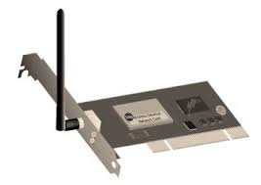

Figure : NIC (www.elprocus.com)

### 2. Servers

This is a software or hardware device that accept reply for request through network.

In a network servers act as a computer or software systems. Servers can be any device

that share or store information. (Team, 2021)

#### 2.1. Types of servers

##### Web Server

Web server is used with a public domain software for access the world wide web.

This server can save information from web to the user computer. (Team, 2021)

##### Proxy server

This server acts as a bridge between host server and client server. Proxy share information from a website to user computer Ip address after it is passes to proxy server. (Team, 2021)

##### Virtual server

In this server its store and connect data over virtual space. Virtual servers are common in Web hosting environments because they are affordable and offer quicker resource control. (Team, 2021) (techopedia, 2018)

##### File transfer protocol server

This server can locate files from one computer to another computer. Every server has an FTP address that users can access through TCP/IP using a browser or an FTP client to connect to. (Team, 2021) (Abba, 2022)

##### Application server

Through virtual server connects these servers join clients to software applications. These applications use operating systems and server hardware. (techopedia, 2018)

##### File server

File server can storers data for many users. File server is in central storage place. (Team, 2021)

##### Database server

This is a large storage space that can organized any multiple programs, in a data architecture database can work independently. (Team, 2021)

##### Mail server

Email server means that emails stores and delivering emails. (Team, 2021)

##### Print server

To print over a network a print server established remote connection with near by computers. (Team, 2021)

## P4 : the inter-dependence of workstation hardware with relevant networking software.

### 1 . VMware Workstation 15.5 Installation

1 – Install VMware.

<https://my.vmware.com/en/web/vmware/downloads/info/slug/desktop_end_user_computing/vmware_workstation_pro/16_0>

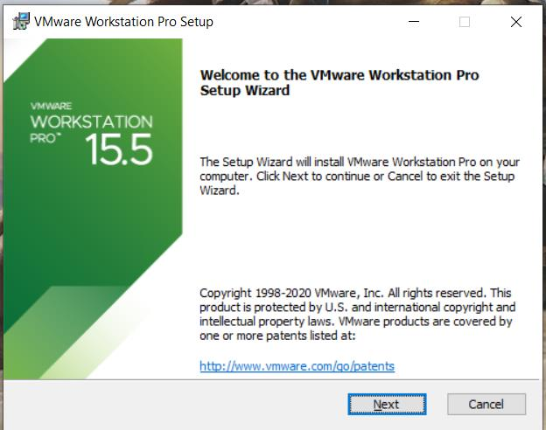

Figure : VMware 1

Now in this interface user should click next button

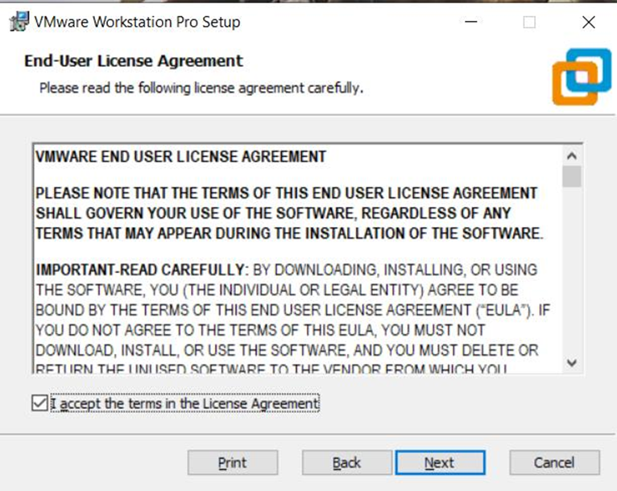

Figure :VMware 2

2: This user license agreement user should click on the square that has a sentence

of “I accept the terms in the license agreement” after that click on next button.

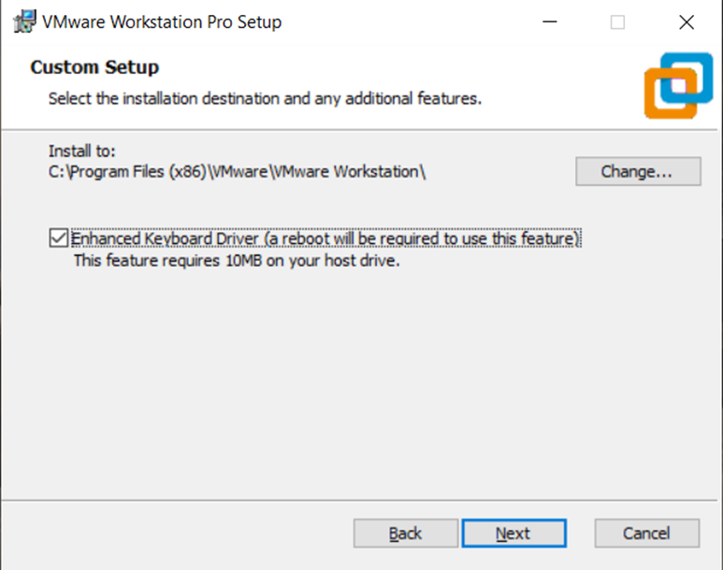

Figure :VMware 3

1. : This custom setup interface user should click above the sentence about “Enhanced

keyboard Driver” and click the next button.

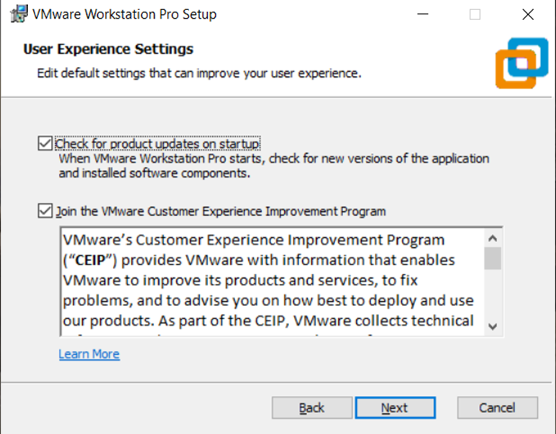

Figure : VMware 4

4: In user experience settings interface user should click Next button

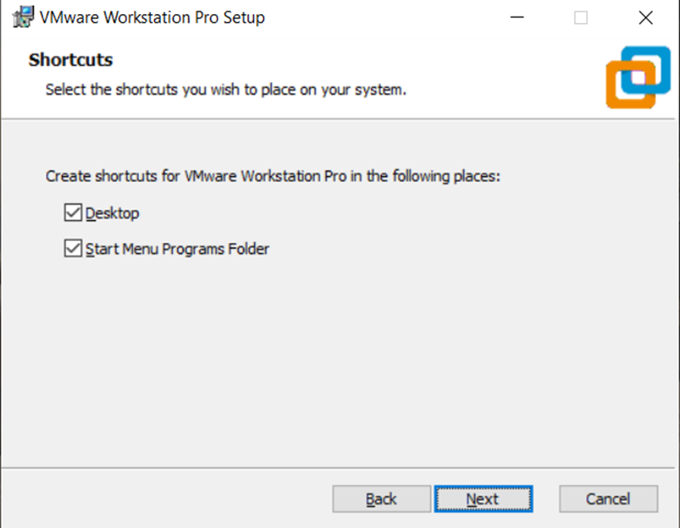

Figure : VMware 5

5: In shortcuts interface user should click next button.

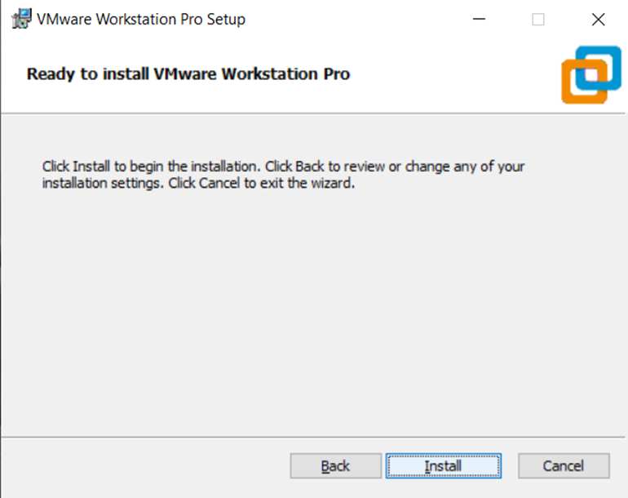

Figure :VMware 6

6: In this interface user should click on install button and it will start to install .

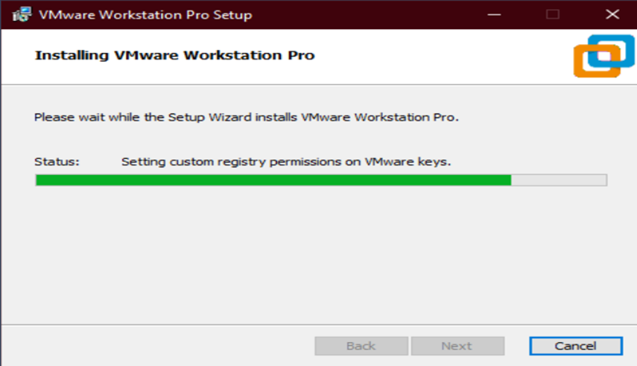

Figure : VMware 7

7: This interface shows the installing of Vmware after installing click the next button.

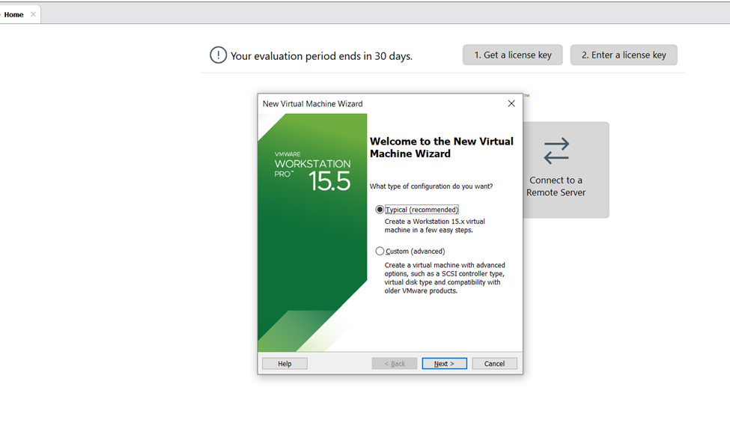

Figure : VMware 8

8: when the Vmware workstation installed then click the new virtual machine and when

this interface appear user should click that shows a sentence about

“typical(recommended)” after that click next button.

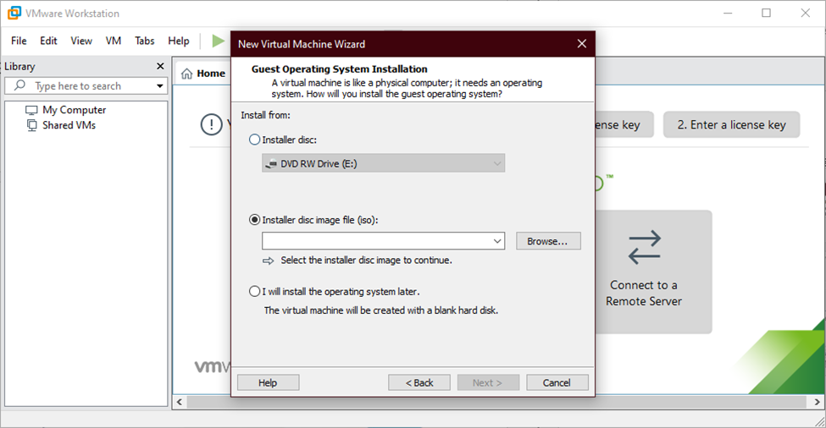

Figure : VMware 9

9: In this interface user must click the browse button and select the disc image file and then

user can click on next button.

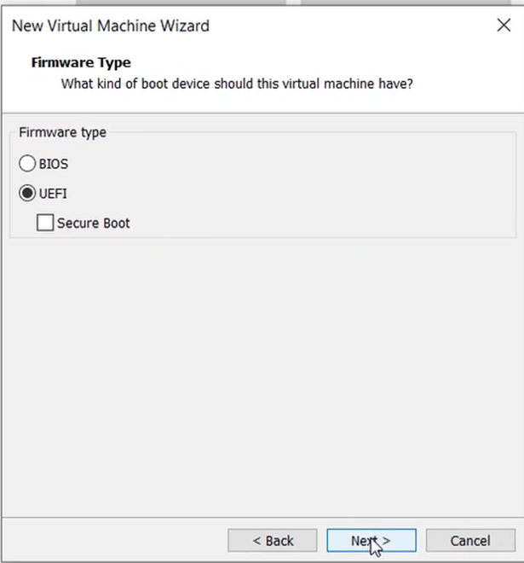

Figure : VMware 10

10: This interface user should click the “ bios” and then click the next button

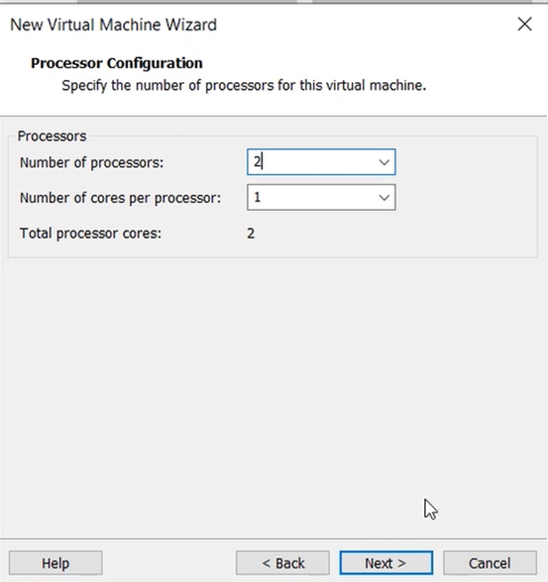

Figure : VMware 11

11 : In this interface user should choose for “number of process” number 2 and for “number

of cores per processor” number 1 and then select next button.

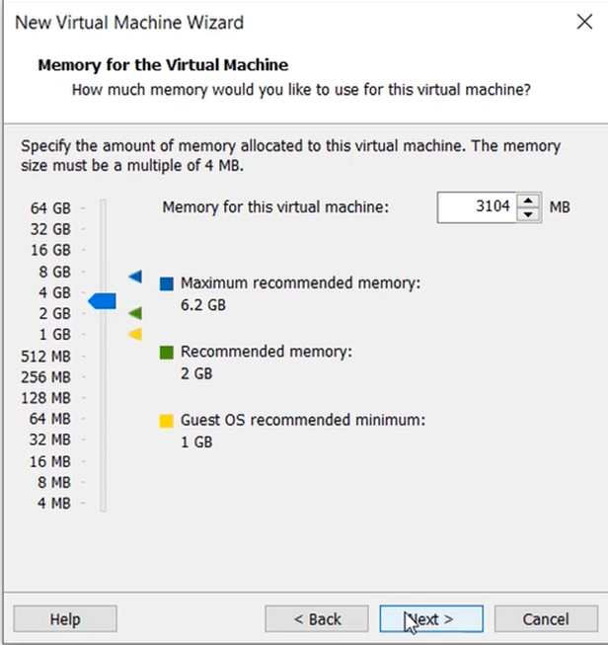

Figure :VMware 12

12 : This interface user should select the “memory of the virtual machine” and the user

select 3104 MB for it and select the next button.

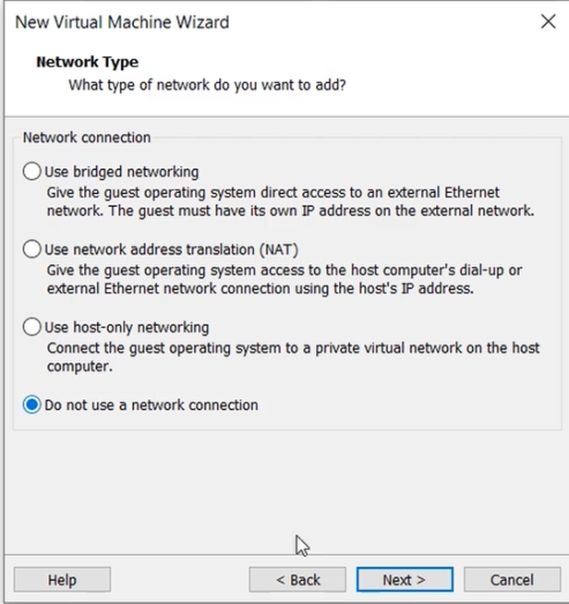

Figure : VMware 13

13: This interface user should click on “Do not use a network connection” and click the next

button.

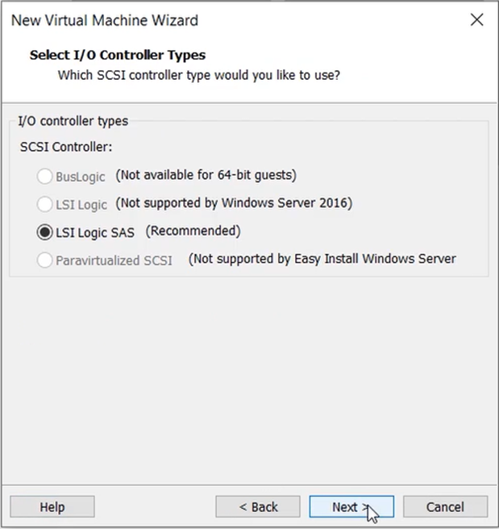

Figure :VMware 14

14: In this interface user need to select next button.

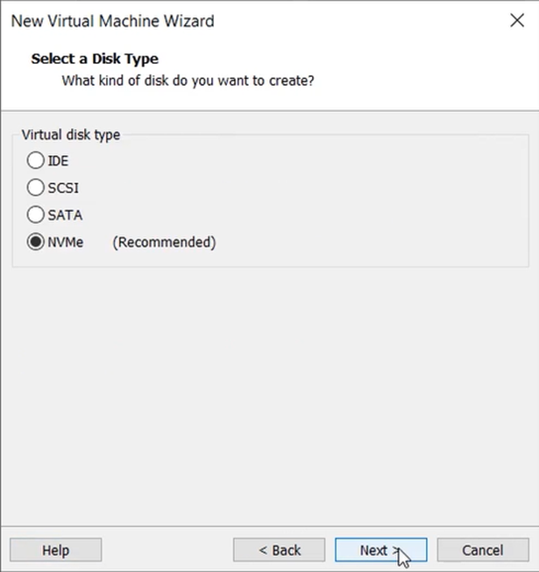

Figure : VMware 15

15 : This interface is about select a disk type then select the disk type of that show “NVMe”

And then click the next button.

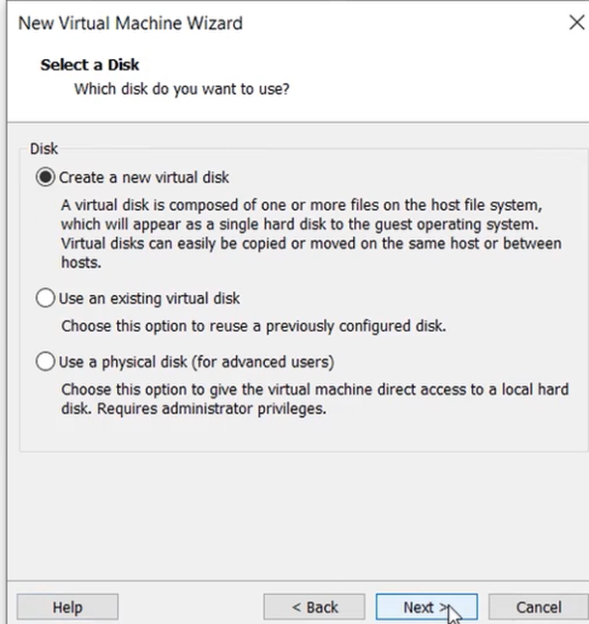

Figure : VMware 16

16: Then click that shows “Create a new virtual disk” and then click the next button.

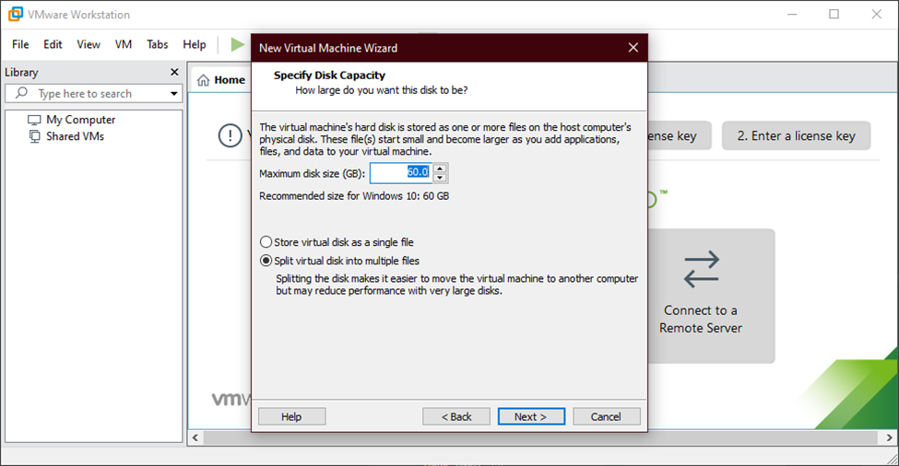

Figure : VMware 17

17: This interface user needs to fill the “maximum disk size (GB)” and then click the “split

virtual disk into multiple files” text and then click the next button.

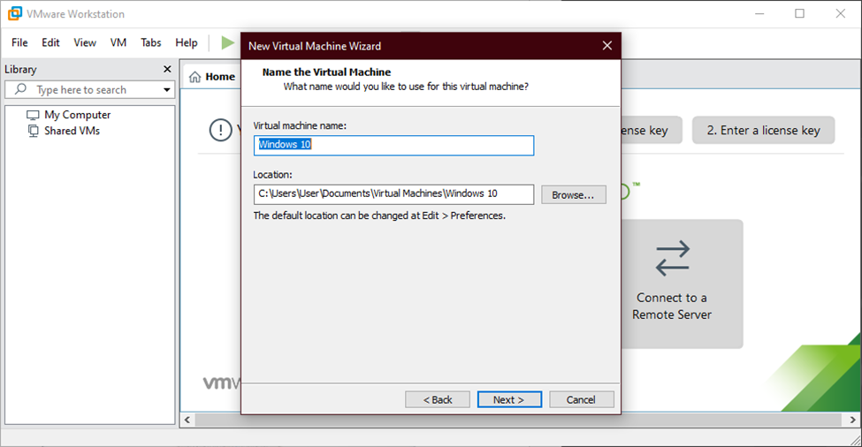

Figure : VMware 18

18: This interface user need to fill a name for “Virtual machine name” and then user should browse a location and fill it then user can click next button.

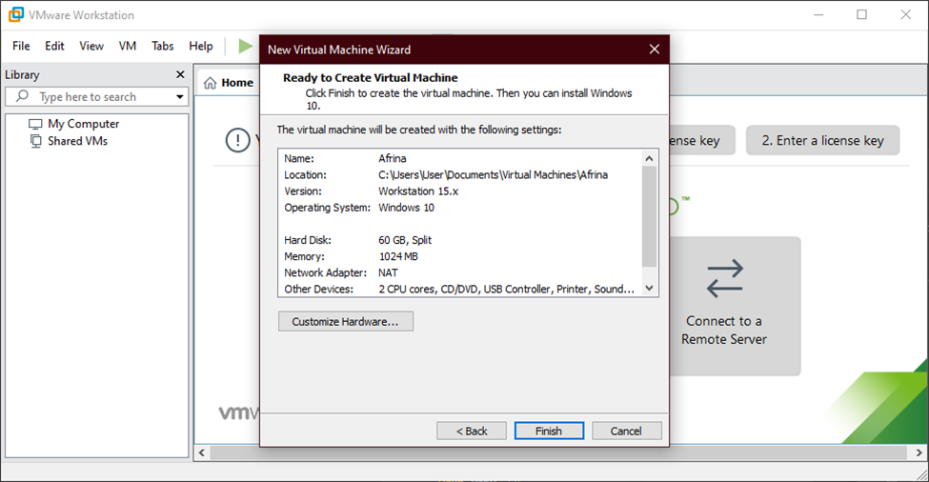

Figure : VMware19

19: When there is interface that called “Ready to create virtual machine” then user can click

the finish buttons.

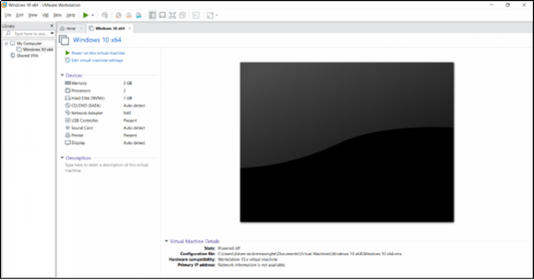

Figure : VMware 20

20: After clicking the finish button the virtual machine is created and this interface will

display on user’s laptop.

### 2. Window server 16 (Installation)

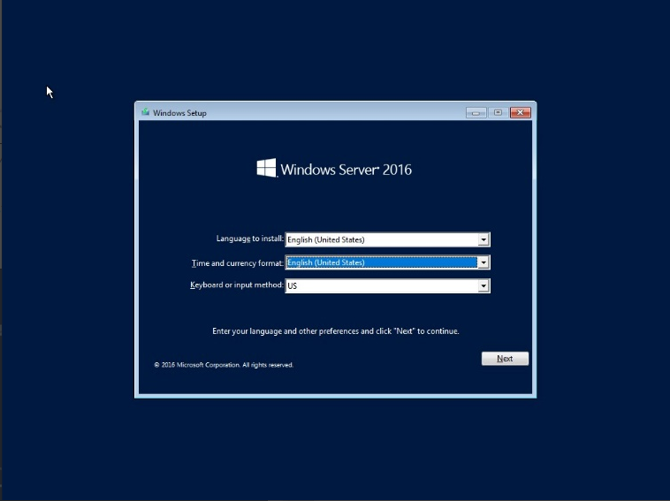

1: when this interface appears user should fill the text of “language to install” , “Time and

current format” and select the “Keyboard or input method” then after all of this user can

click next button.

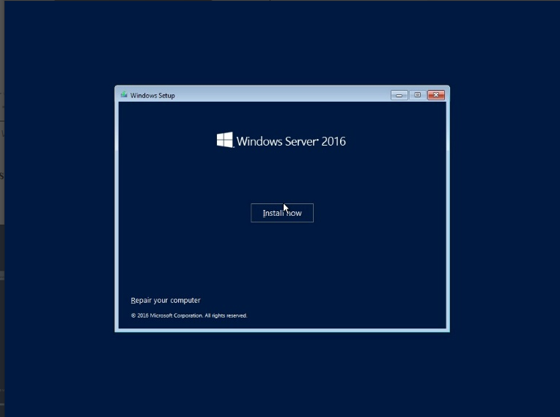

2 : In this interface user should click the “ install now” to process it.

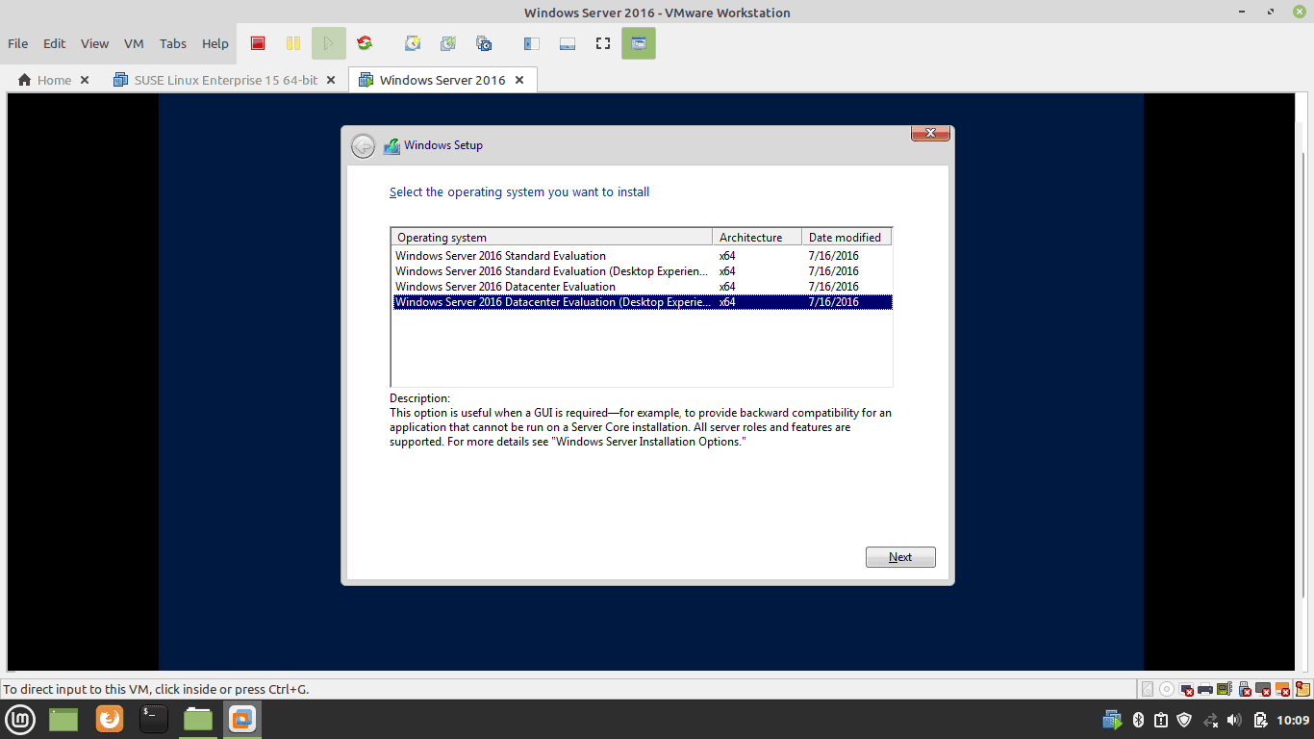

1. : Select the version that user wants and then click the next button.

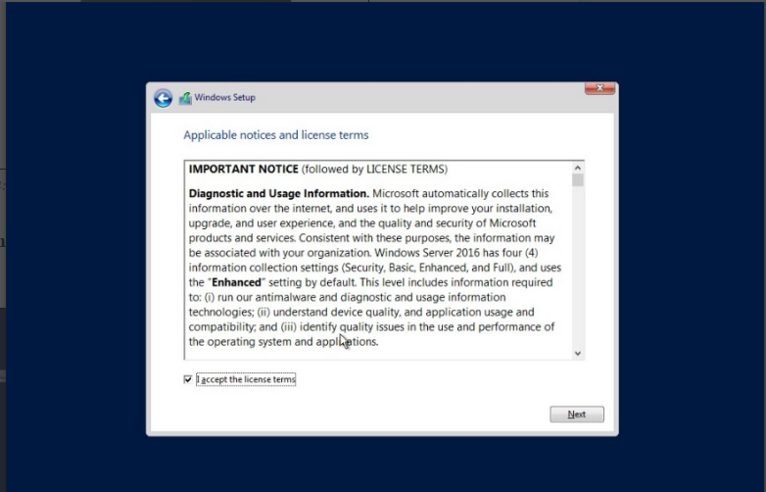

1. : In this applicable notice and license terms interface user should click the next

button.

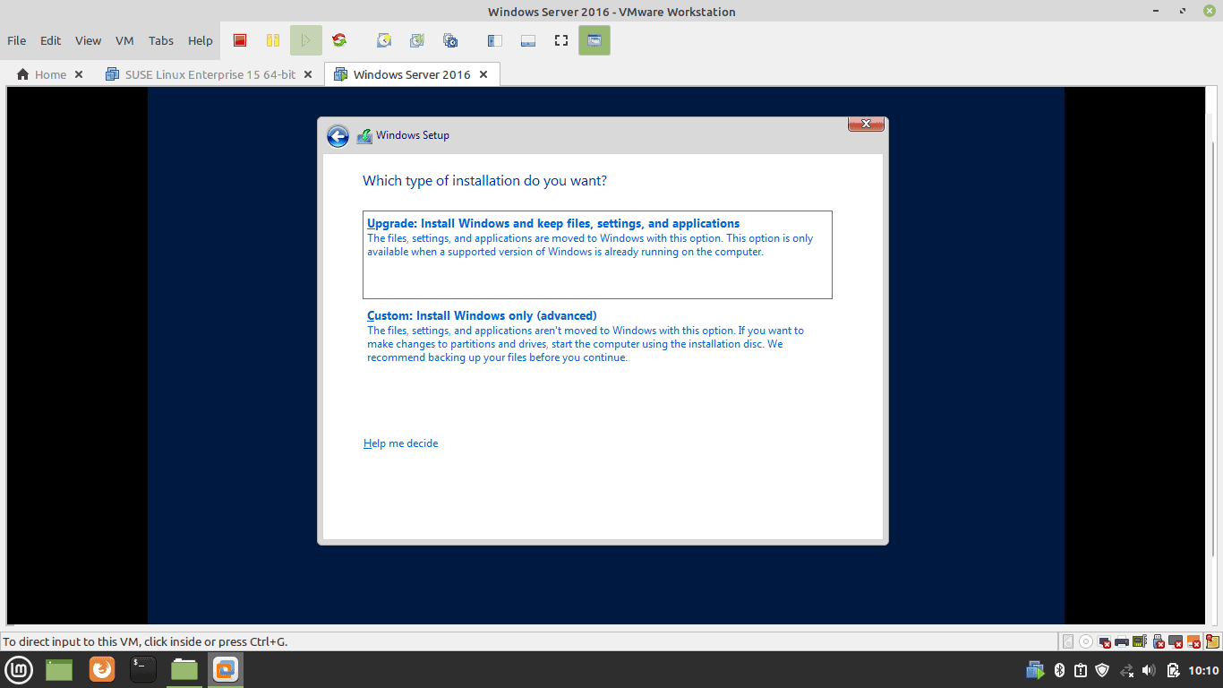

1. : In this interface user can select “Upgrade” or “Custom” and select it to go to other

interface.

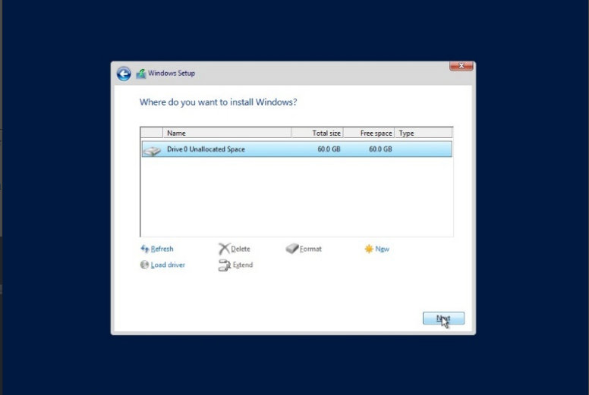

1. : Select the “Drive 0 Unallocated Space” and click the Next button.

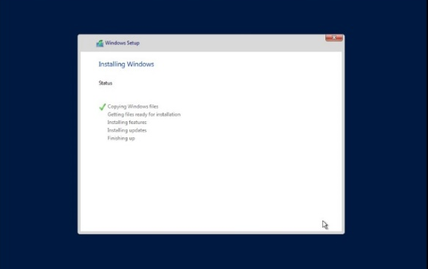

7 : In this interface user can see that windows server is installing .

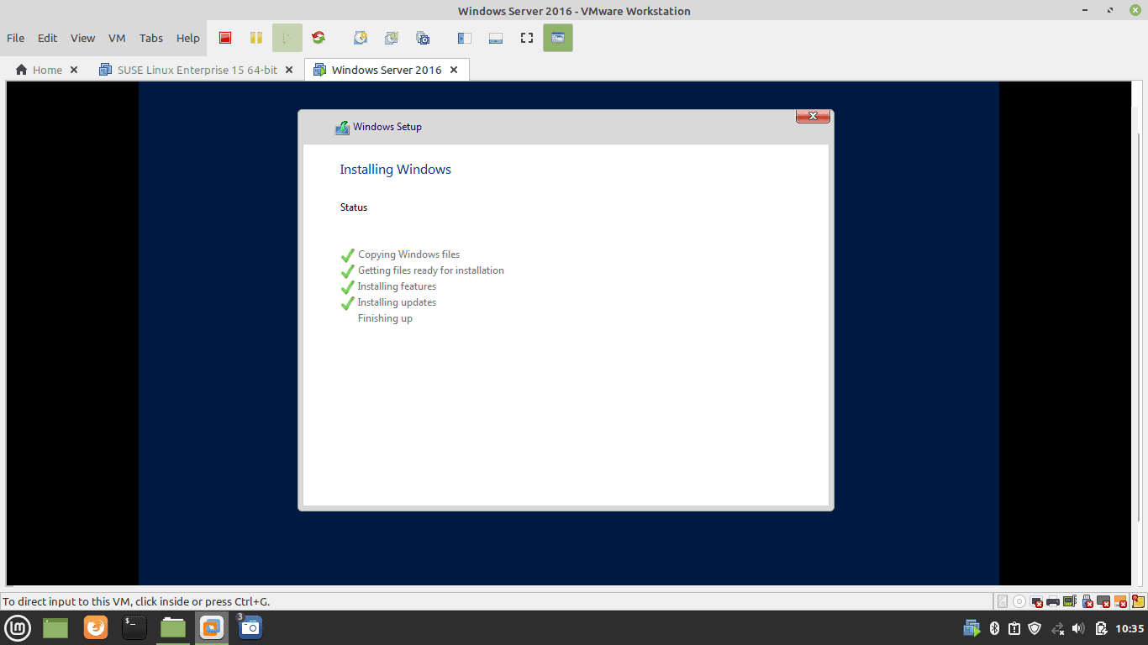

8 : When the installing process done its interface like this.

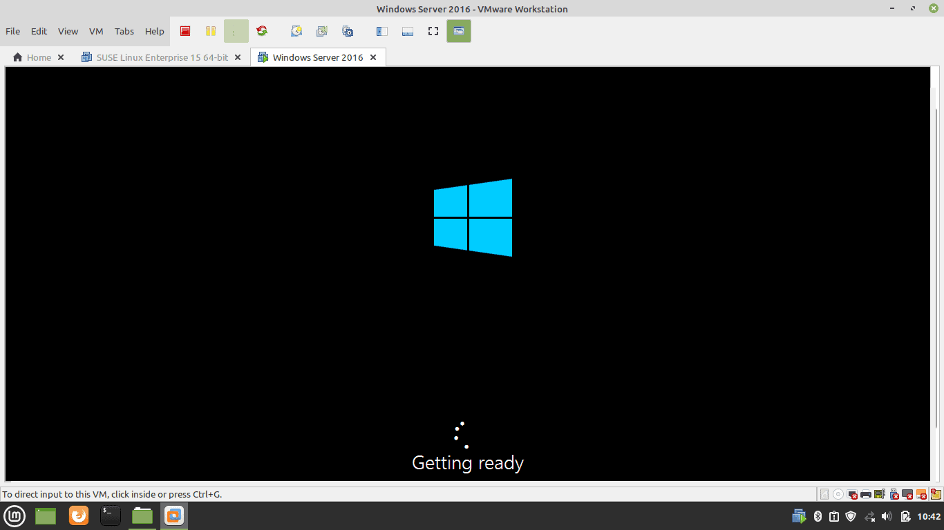

9 : After the installation done it will get ready for the other interface.

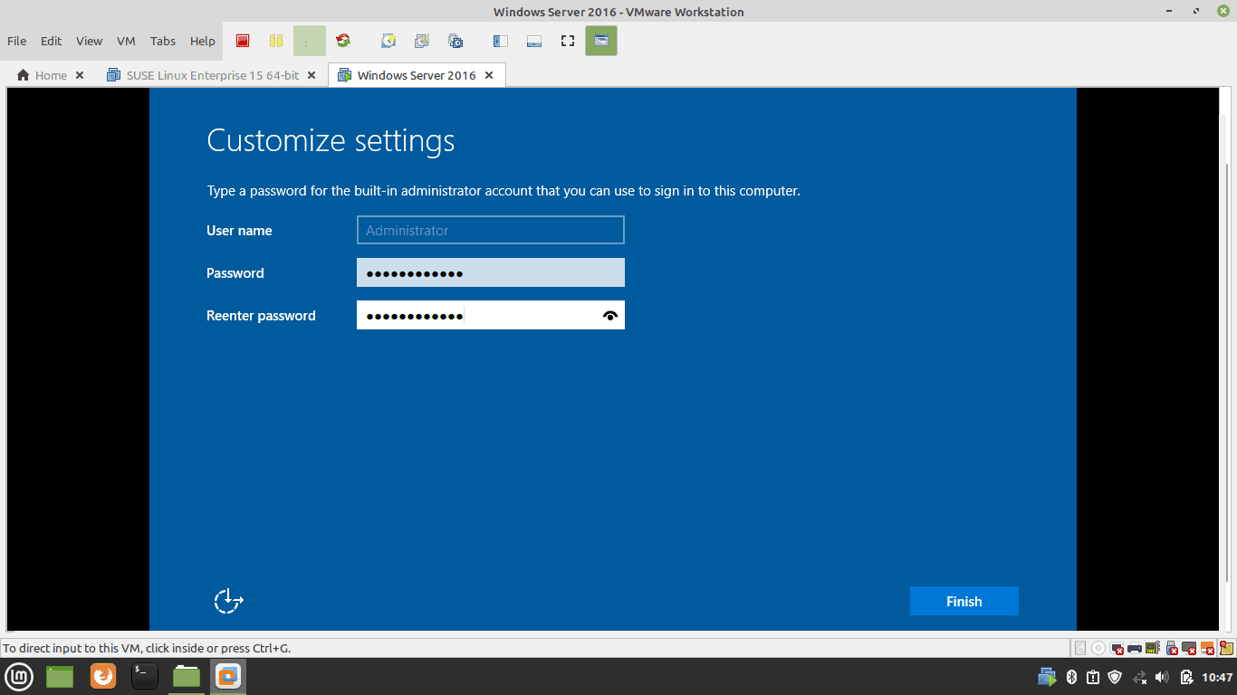

10 : Then this interface appear in this user can fill the user name and passwords and then click then finish button.

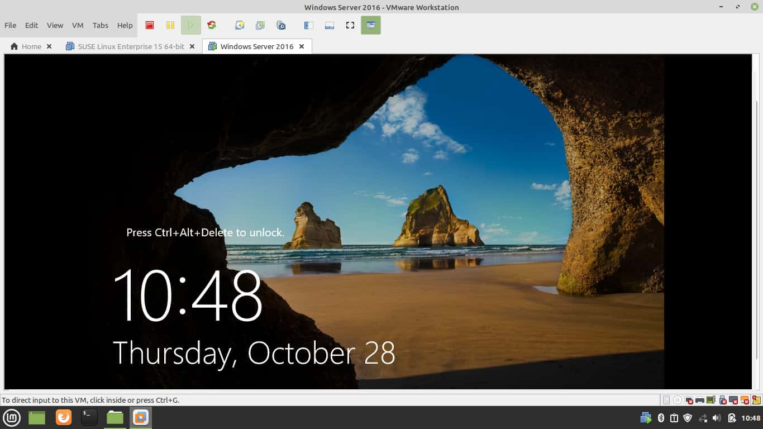

11 : After that interface this interface will appear.

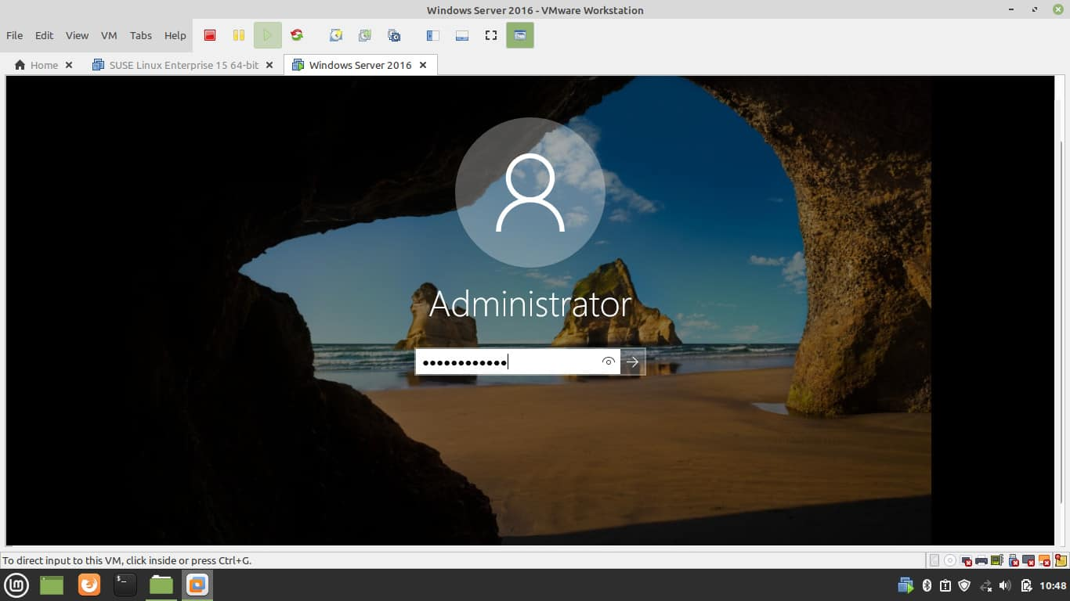

12 : This login form will appear.

* This is how window server 16 will install.

## M2 : A range of server types and justify the selection of a server, considering a given scenario regarding cost and performance optimization.

### 1.Range of Server Types

|  |  |  |  |
| --- | --- | --- | --- |
| **Server Type** | **Sample** | **Features** | **Price (RS)** |
| Dell EMC PowerEdge  T440 Tower server |  | * Has a Intel Xeon Processer. * Memory is 16 DDR4 DIMM SLOTS * Brand is Dell. * Drive Bays are Up to 4or 8x3.5 * Security is TPM 1.2/2.0 optionall * Bezel is Optional Security bexel. | Rs.135000.00 |
| PowerEdge T430 Tower server |  | * It has 2 powerful sockets * Processor is intel E5-2600 * Maximum RAM – 384GB | Rs 122,000.00 |
| HPE ProLiant ML 30 |  | * This is designed for small offices * There is a 64GB memory. * System support 4X SATA drives and M2 slot integrated. | Rs 195,000.00 |
| Lenovo think ST250 V2 Towe server |  | * Memory is up to 128GB * Single fixed power supply is used for this. * 2XGBE on board ports in Network Interface. |  |

### 2. Suitable server for the scenario.

Author thinks that for Syntax Solution Company Suitable server is the Dell EMC

PowerEdge T440 Tower because it has 16 DDr4 memory. Author thinks that for this

company it has many users, and this is large network system. In this period most

companies and workers use this for make their work easier. This has a very good security

and no worry to at all. But the only thing is this price is very high.

## D1: The topology and protocol selected for a given scenario

### Topology for given scenario.

For the Syntax solution company author guess that for the network system they

should choose the Hybrid topology to connect because for this type of network

system user can connect a tree topology with a star topology then the work will more

easier to do and author suggest another topology that is star topology because

there has a central device in this topology then the network can control with the

central device.

### Protocol for the given scenario.

Author suggests that for the syntax solution company the best protocol is that

Hyper Text secure (HTTPS). This protocol can secure the web pages and websites.

And it is useful when people using websites because if it is a not secure web site

people can disconnect it.

# LO3: Design a efficient networked systems

## P5: A networked system to meet a given specification

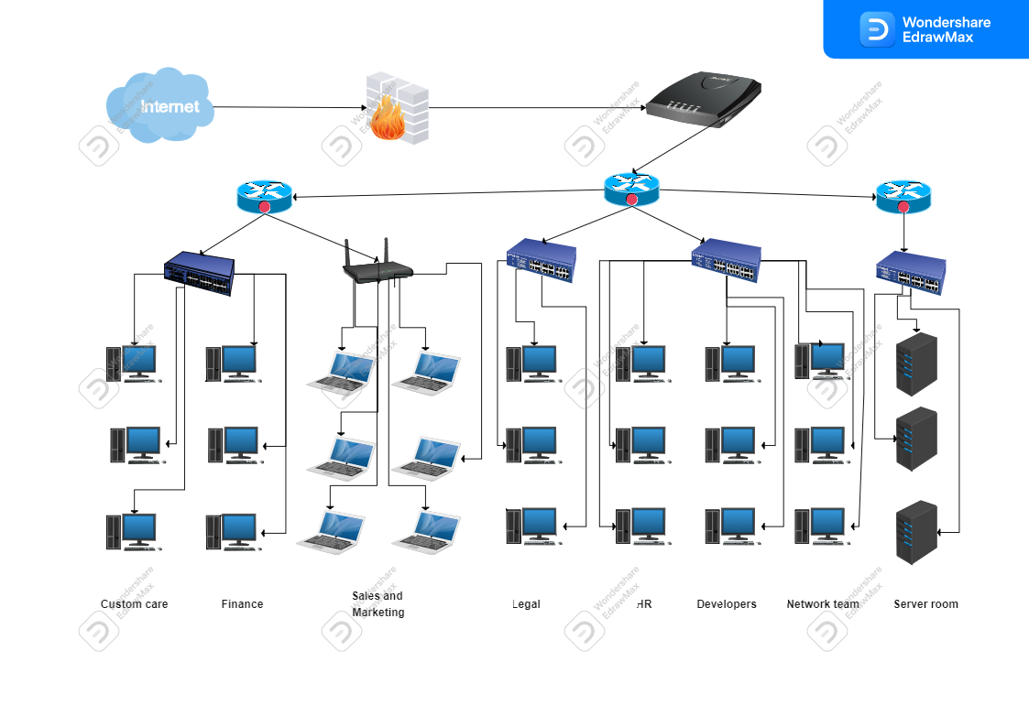

Figure : A networked system to meet a given specification

This is a design of authors Network, and it is design in Edrawmax tool. This network

system has 8 departments. The departments are used routers, switches, pc, laptops and

also, Wi-Fi routers. The departments and the number of users used are displayed on

below. That are,

* Customer care - 10 users
* Sales and marketing - 20 users
* Finance - 25 users
* Legal - 5 users
* HR - 10users
* Developers - 55 users
* Network team - 5 users

## P6: Test and evaluate the design to meet the requirements and analyse user feedback

### 1. User Feedback Form of Syntax Solution Company.

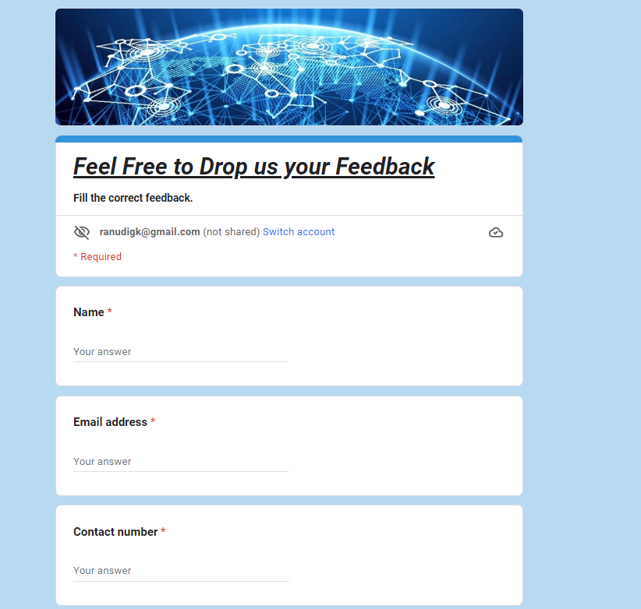

Figure : User Feedback Form 1

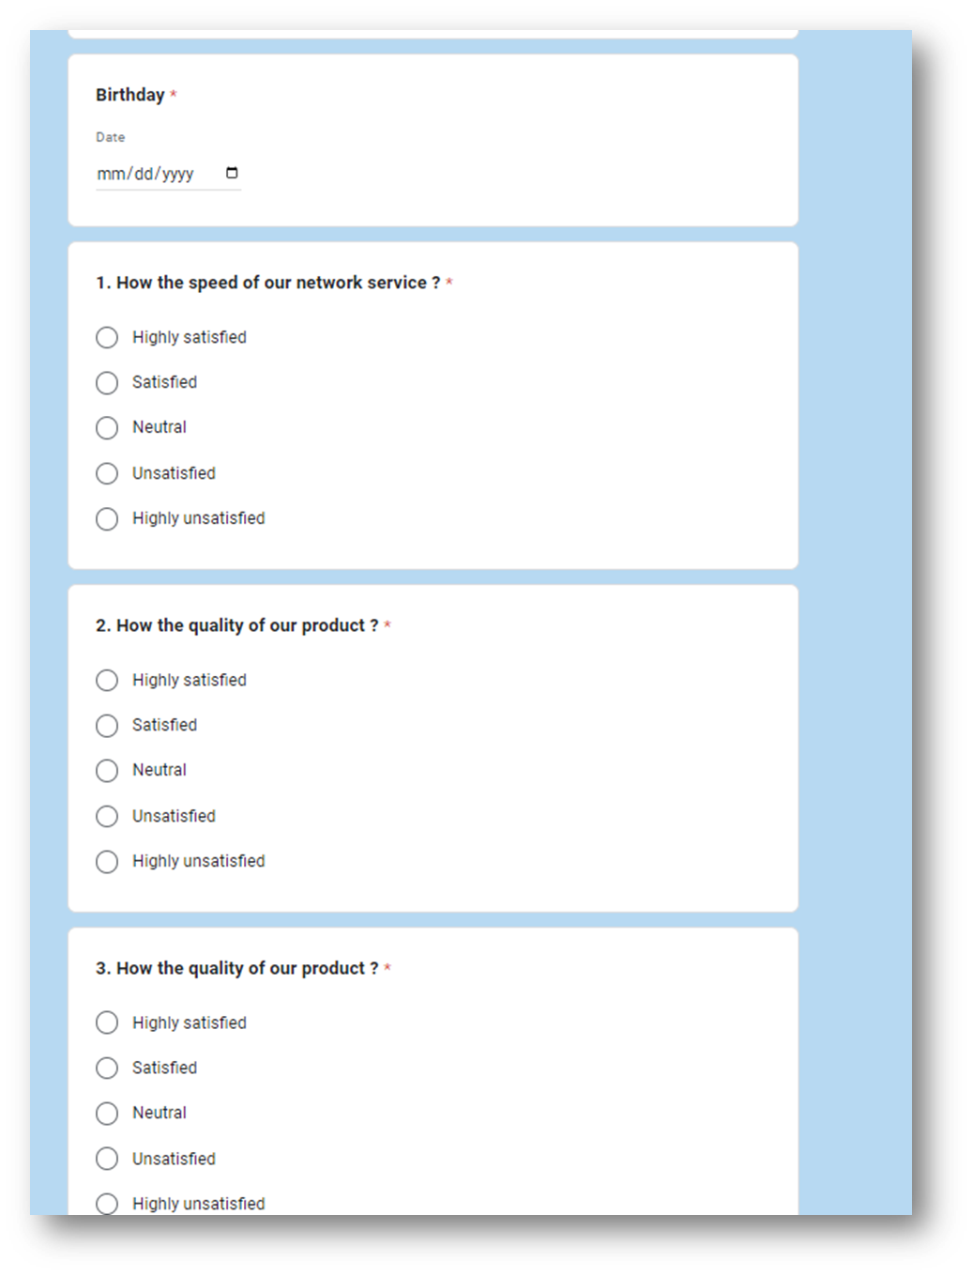

Figure : User Feedback Form 2

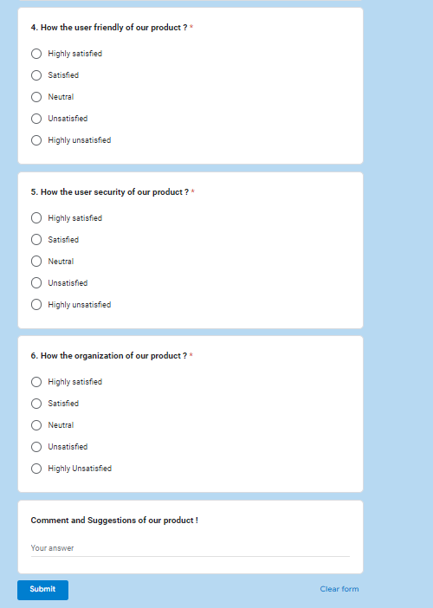

Figure : User Feedback Form 3

#### User response Form of Syntax Solution Company.

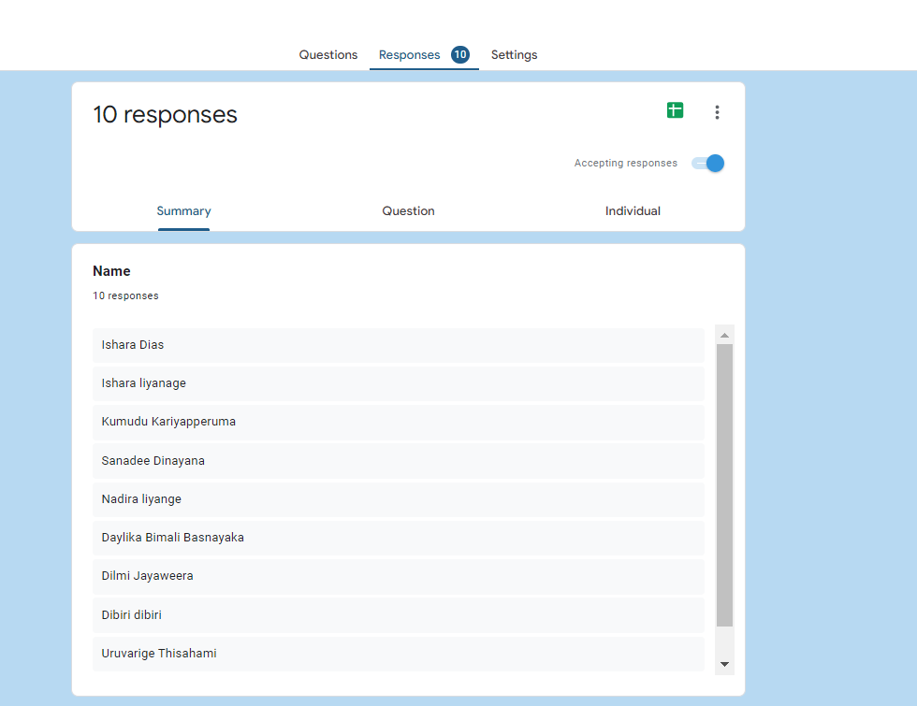

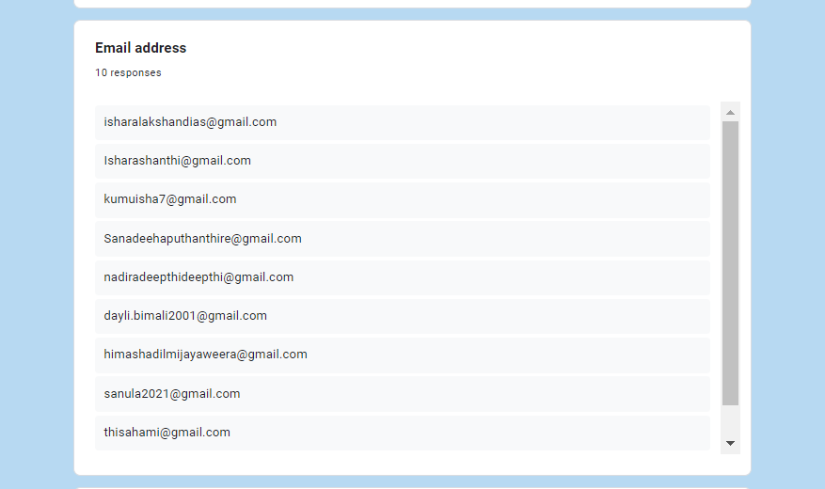

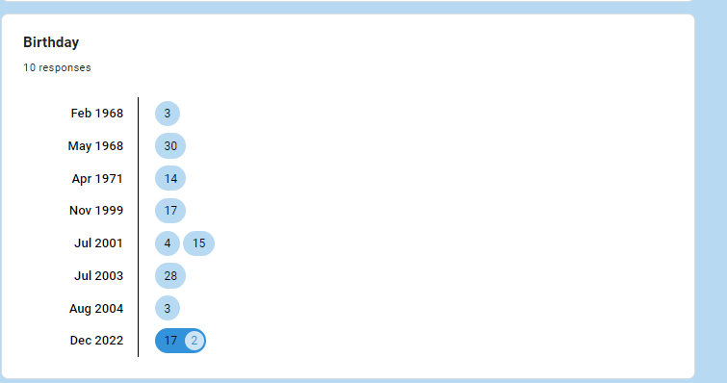

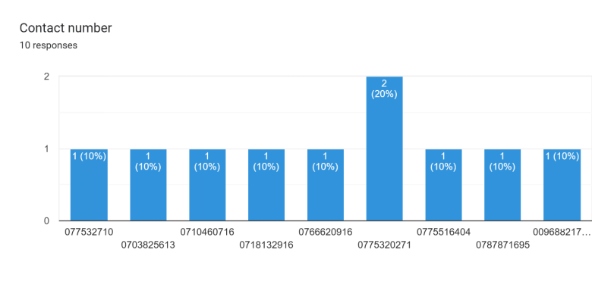

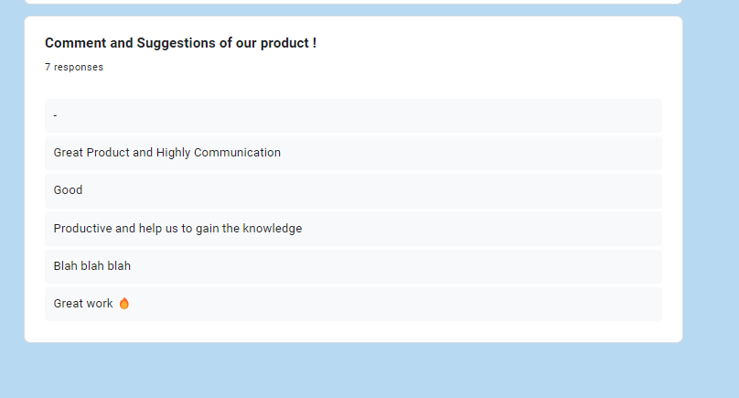

### 2. Analaizing the user feedback form.

In this part user have the responses of the questions about the Syntax Solution company.

#### How the speed of the network service?

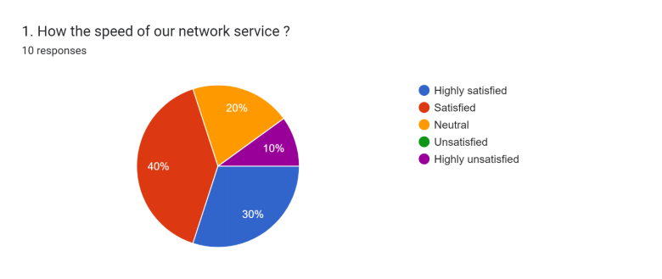

In this pie chart user can realize that 30% of people satisfied about the speed of the network service while 10% of people are highly unsatisfied. So, user can think that this means that the network speed is okay. The most people are Satisfied about the speed of the network 40% of people satisfied about the speed of the network service. Some people are chosen neutral of the speed of the network that percentage is 20%. However overall can guess that speed of the network is enough.

#### How the quality of the product?

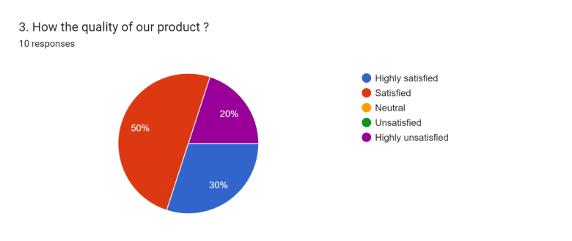

This Pie Chart user can see about Responses about the quality of the product. Highly

satisfied people are the percentage of 30% but most people are satisfied about the

quality of the product the percentage of it is 50%. The percentage of 20 is the people

that choose highly unsatisfied. In this pie chart user can guess that the quality of product should made more quality.

#### How the user friendly of the product?

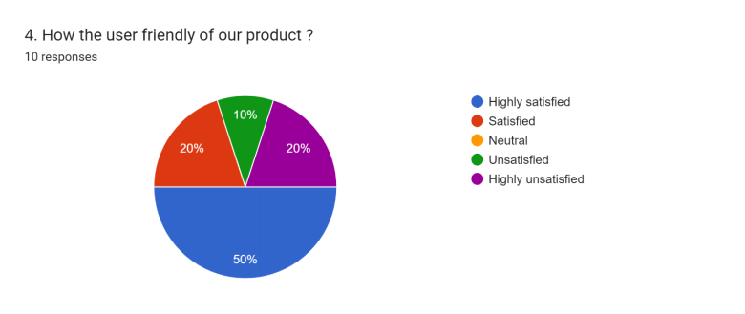

In this Pie Chart user can realize that the user friendly of the product. 50%

people choose highly satisfied about the product that means a half of the people. Equal

number of percentages that means 20 percent of people choose Satisfied and highly

unsatisfied and 10% of people choose unsatisfied. This pie chart realized that it very

good for the people.

#### How the Security of the product?

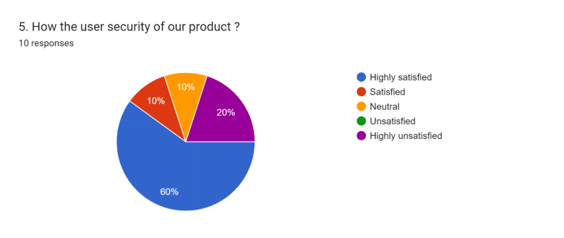

The above pie chart shows the security of the product and 60% of people choose the

highly satisfied and equal number of people that means 10% choose satisfied and

neutral. But 20% of people choose unsatisfied of this security of the product. Over role

user can guess that security is very good of this product.

#### How the organization of the Product?

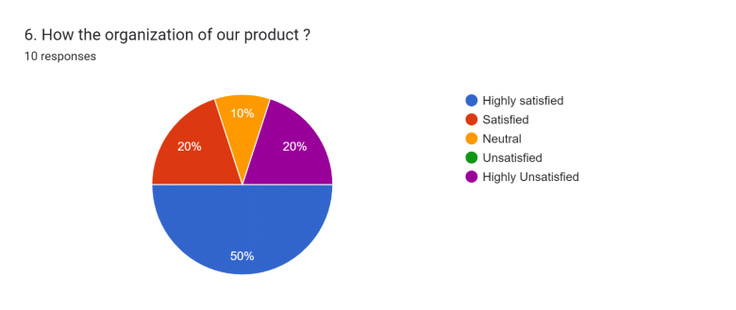

This pie chart shows the organization count of the product. 50% people choose Highly

satisfied about the organization of this product. Equal percentage about 10 people

response that this product organization is satisfied and highly unsatisfied. There are also

10% of people choose neutral. All of this pie chart user can think that they have achieve

their customer’s needs.

## M3: Install and configure network services and applications

When user select a operating system, they should need to look after some point such

as,

* What are the agreements that user should agree?
* What is the purpose of configuring the operating system.

How ever author choose a operating system for the syntax solution company It is

windows 11 because when compare the windows 11 and windows 10 operating system

windows 11 features are better than windows 10. Let’s look the features of windows

1. vs windows 10.

### 1.Features of windows 11 vs windows 10

|  |  |  |
| --- | --- | --- |
| **Feature** | **Windows 10** | **Windows 11** |
| **Generation** | * Last version of Windows | * Latest version of Operating systems |
| **Released Date** | * 2015 July 15 | * 2021 June 24 |
| **Functionality** | * Android | * MAC OS |
| **Installations** | * Can install only windows apps in the store. | * Can install Android, IOS and Windows apps. |
| **Ram** | * Minimum 2GB RAM | * Minimum 4GB RAM |
| **Storage** | * 32GB | * 64GB |
| **The adjustment of the start menu** | * Adjusted the screen of start menu to the left side | * Adjusted the screen to the center and user can adjust it. |

### 2. Configuring the Network System.

Author in this section explaining the configuring part with using authors network design

to clarify the part.

#### Configuration Part of PC and servers

##### 1. Custom care Department

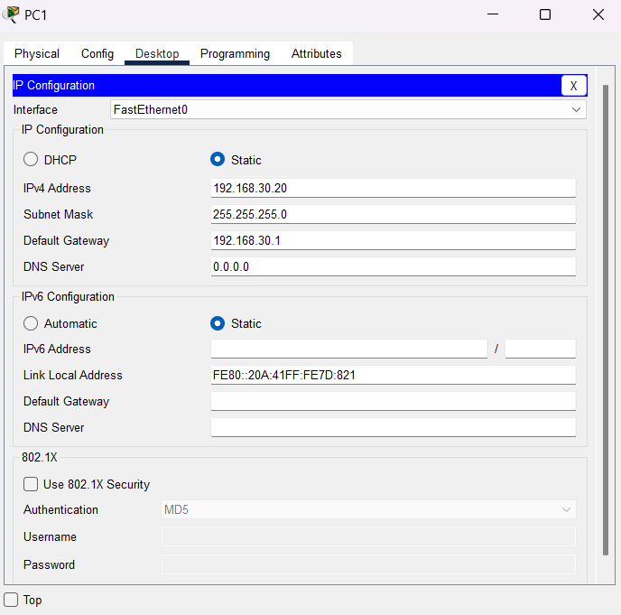

Figure : Custom care Department PC

* In this interface author used IP address as 192.168.30.20 and for the default gateway used 192.168.30.1.

#### 2. Finance Department

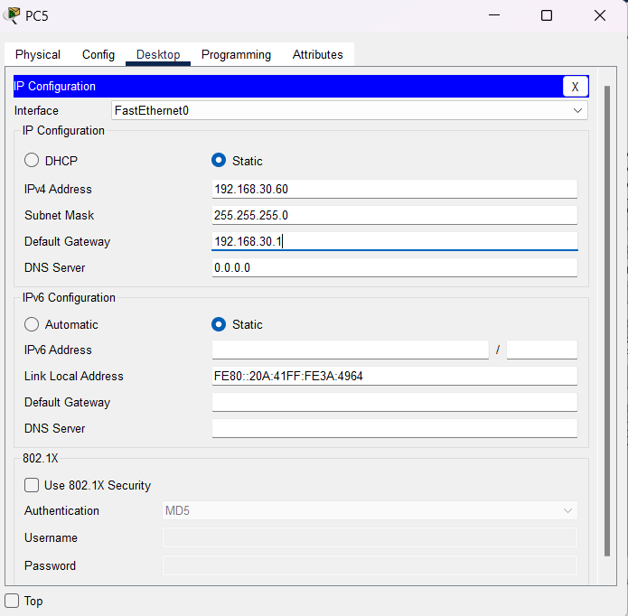

Figure : Finance Department PC

* In this interface author used IP address as 192.168.30.60 and for the default gateway used 192.168.30.1.

#### 3.Sales and Marketing Department

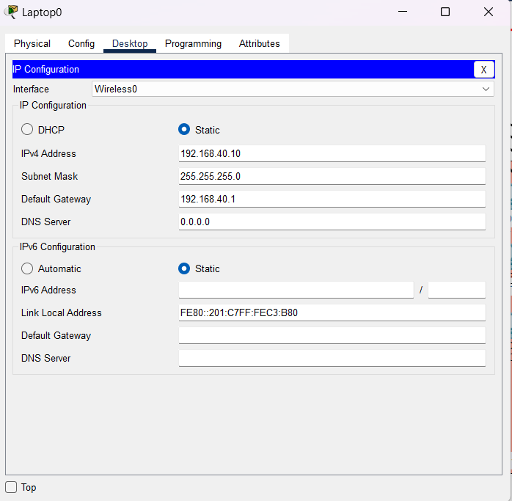

Figure : Sales and Marketing Laptop

• In this interface author used IP address as 192.168.40.10 and for the default gateway used

192.168.40.1.

#### 4.Legal Department

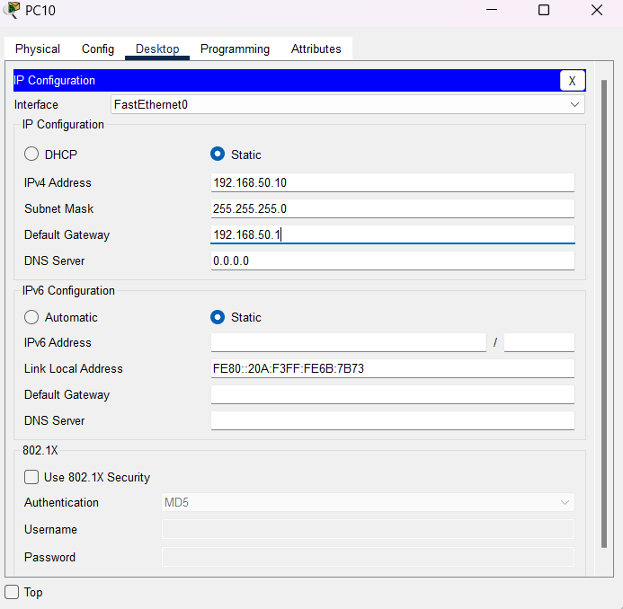

Figure :Legal Department PC

• In this interface author used IP address as 192.168.50.10 and for the default gateway used

192.168.50.1.

#### 5.HR Department

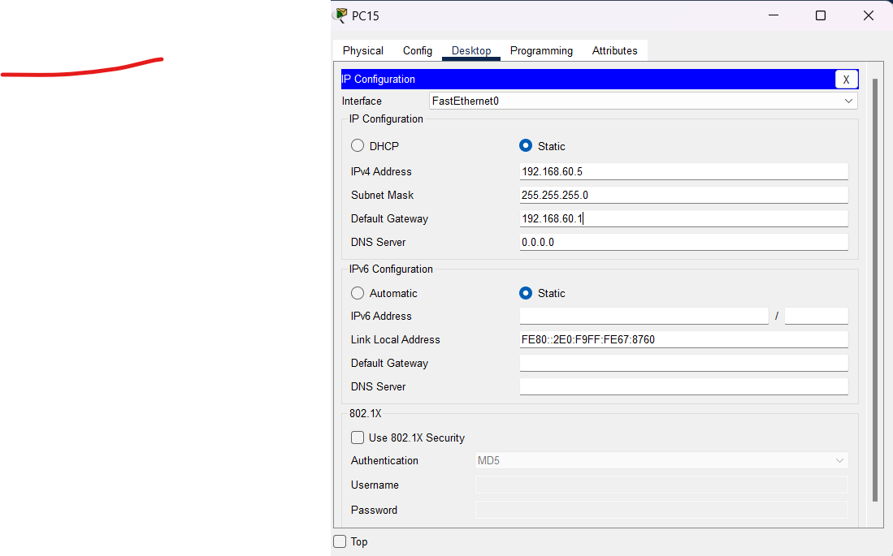

Figure : HR Department PC

• In this interface author used IP address as 192.168.60.5 and for the default gateway used

192.168.60.1.

#### 6.Developers Department

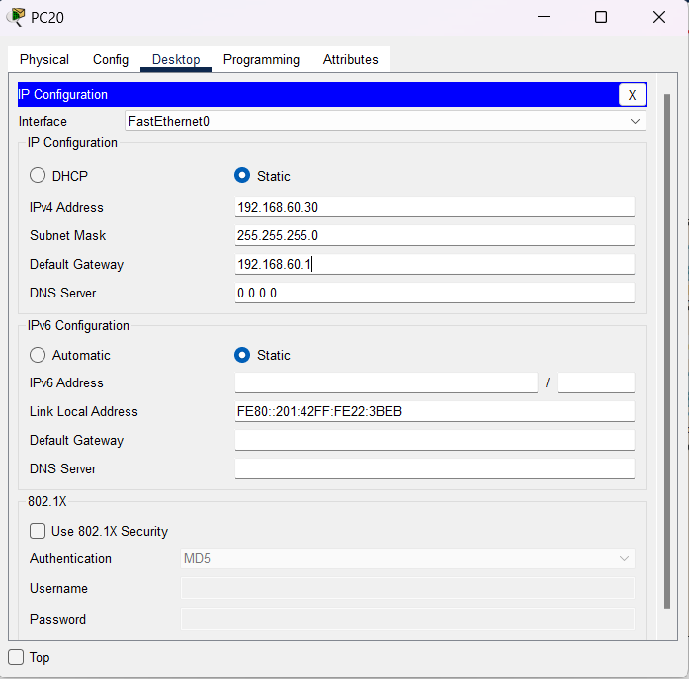

Figure : Developers Department PC

• In this interface author used IP address as 192.168.60.30 and for the default gateway used

192.168.60.1.

#### 7.Network Team Department

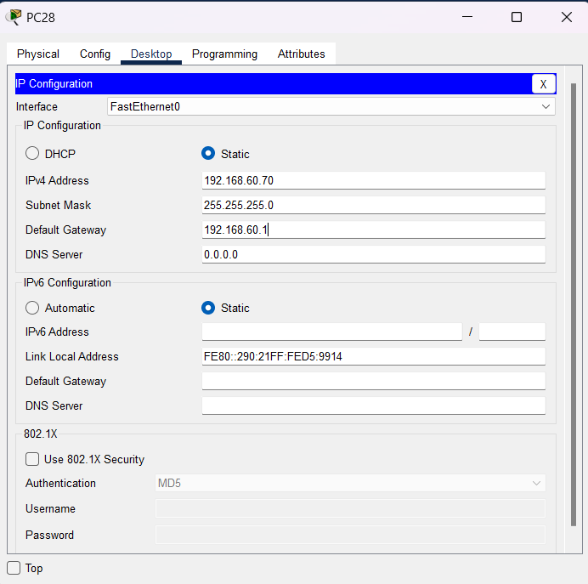

Figure : Network Team Department PC

• In this interface author used IP address as 192.168.60.70 and for the default gateway used

192.168.60.1.

#### 8.Server Room Department

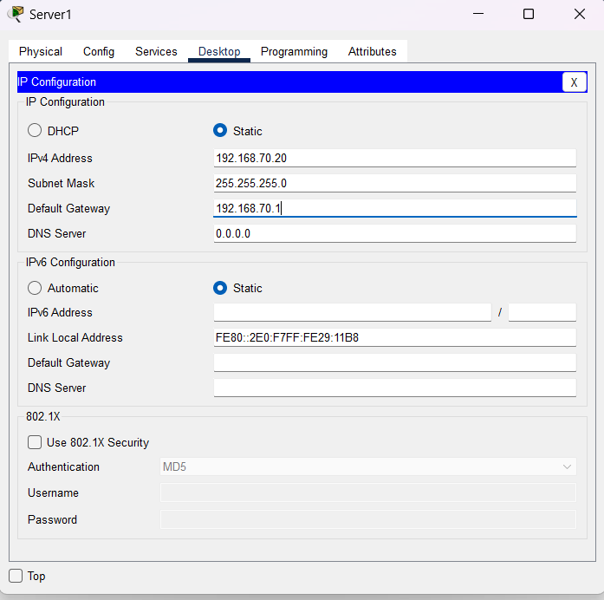

Figure : Server Room Department PC

• In this interface author used IP address as 192.168.70.20 and for the default gateway

used 192.168.70.1.

### 3.Router Configuration

#### Router 0

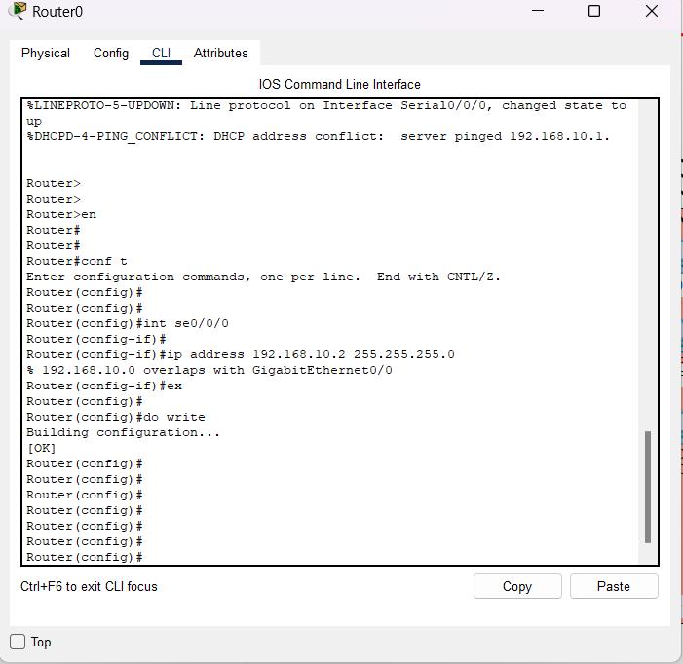

Router 0

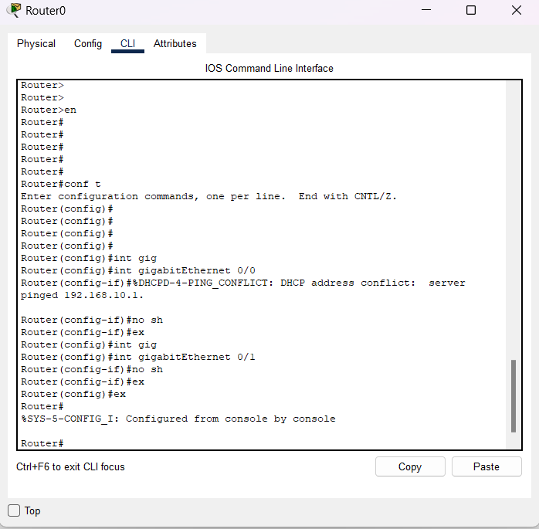

Router 0

#### Router 1

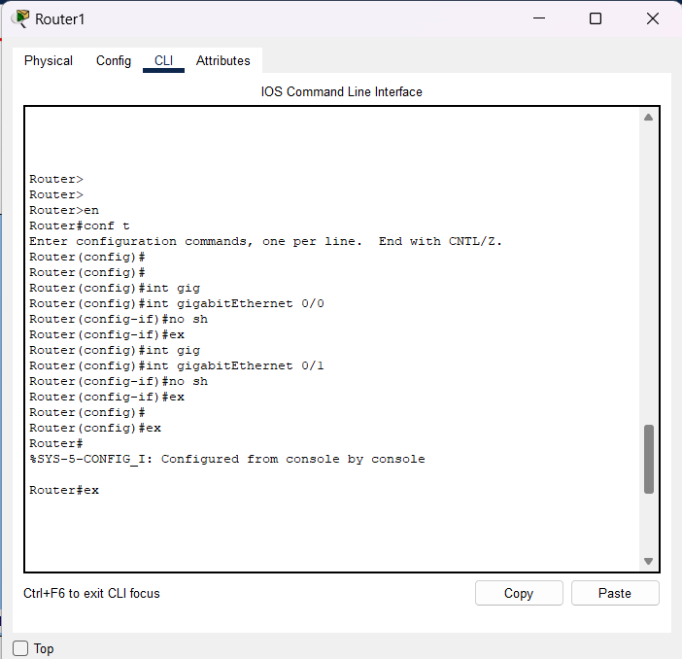

Router 1

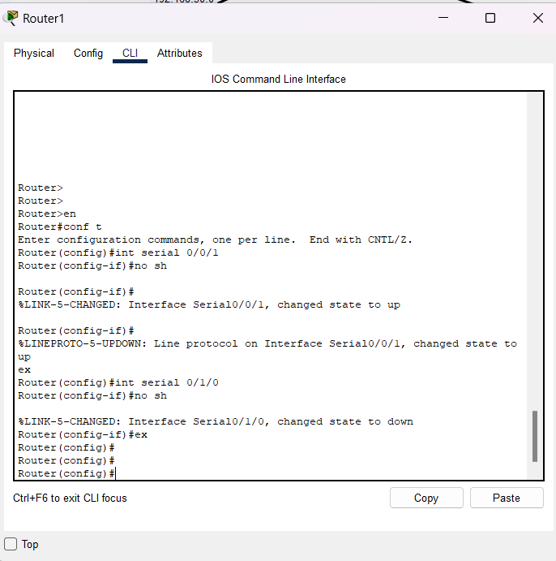

Router 1

#### Router 2

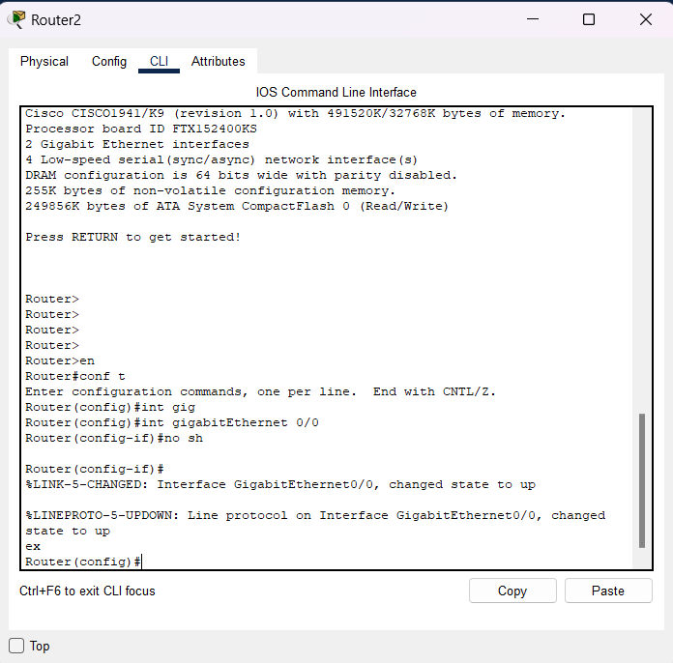

Router 2

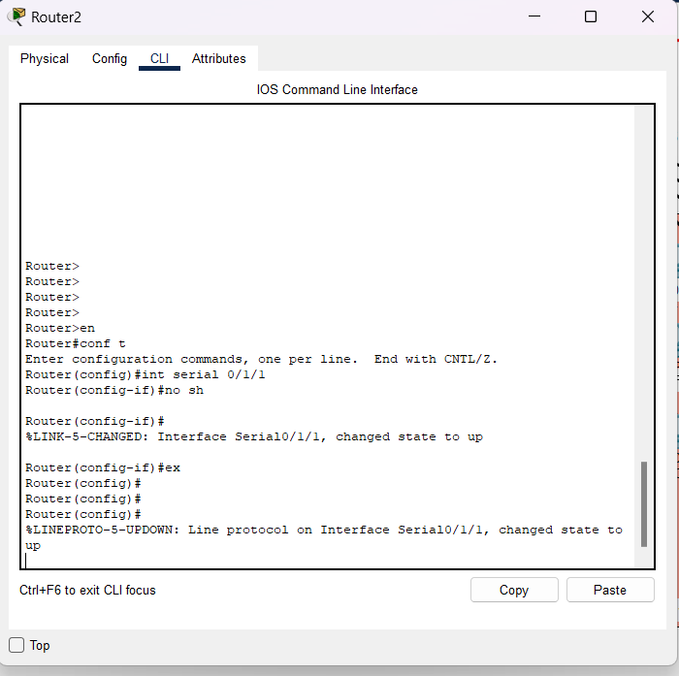

Router 2(1)

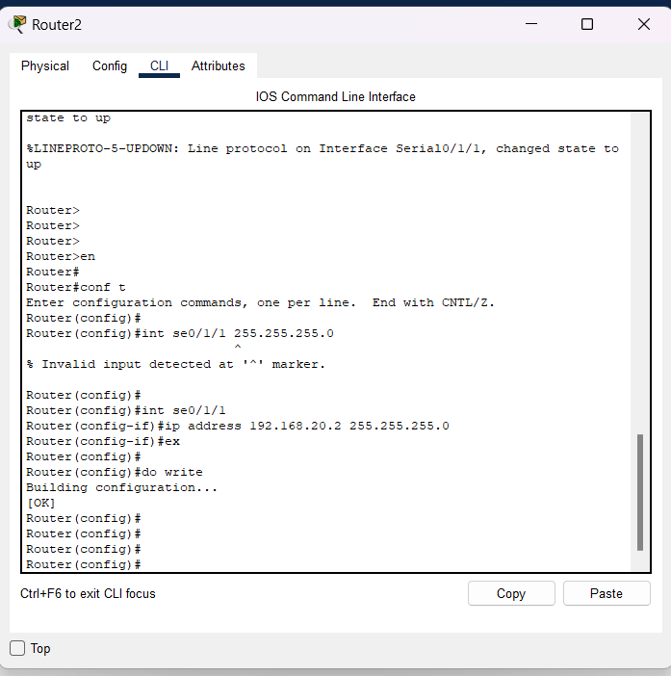

Router 02(2)

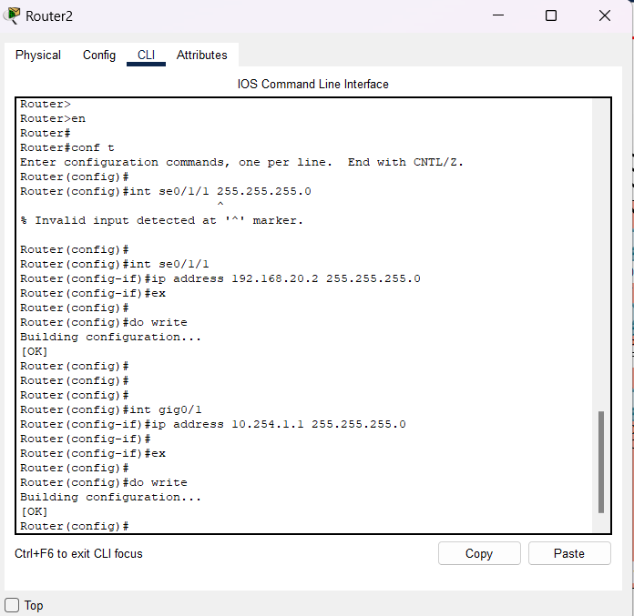

Router 02(3)

### 4.Switch Configuration.

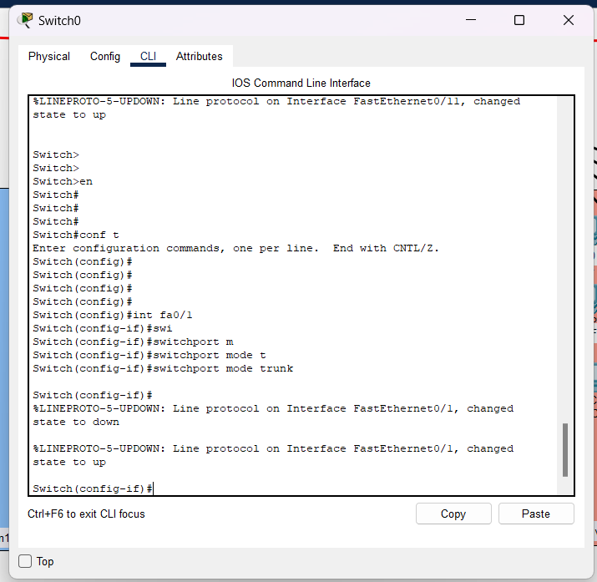

Switch 0

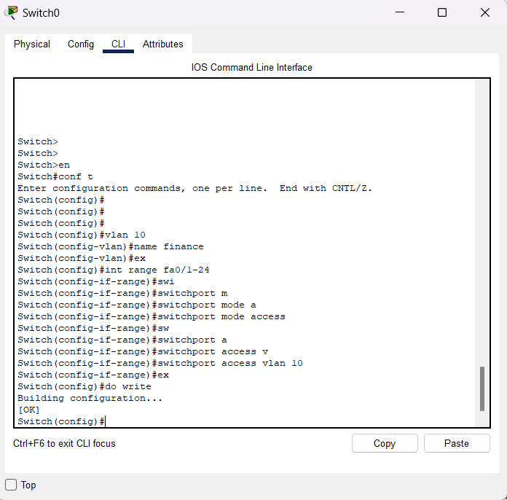

Switch 0(1)

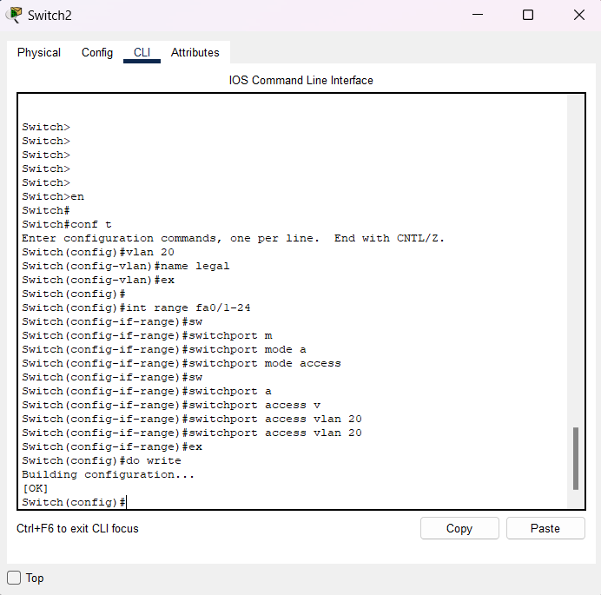

Switch 2

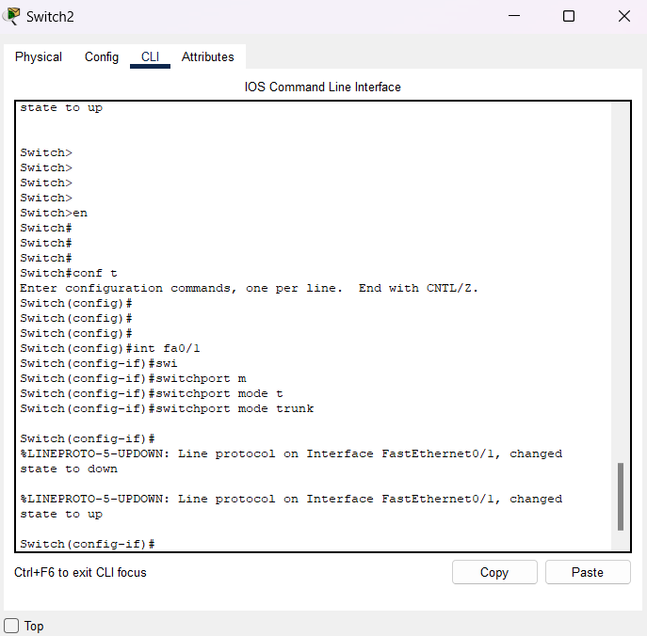Switch 2 (1)

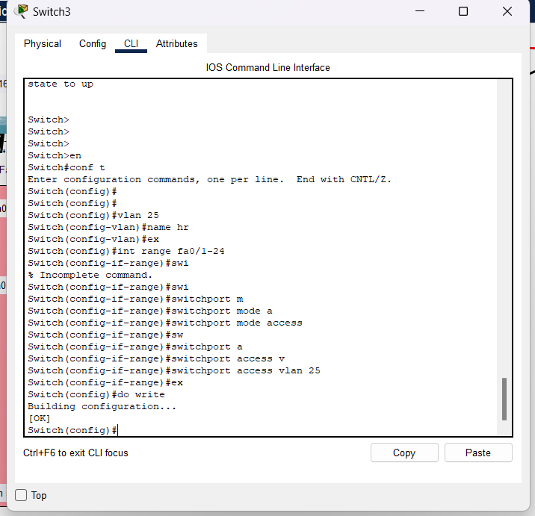

Switch 3

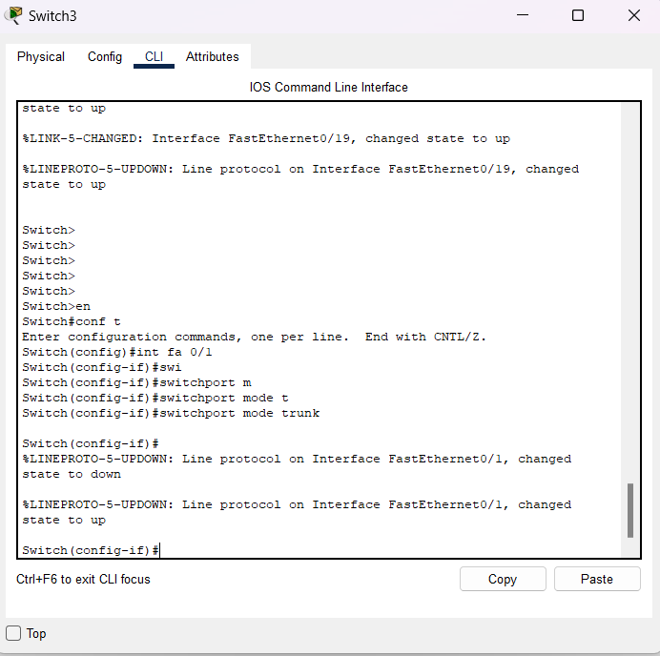

Switch 3(1)

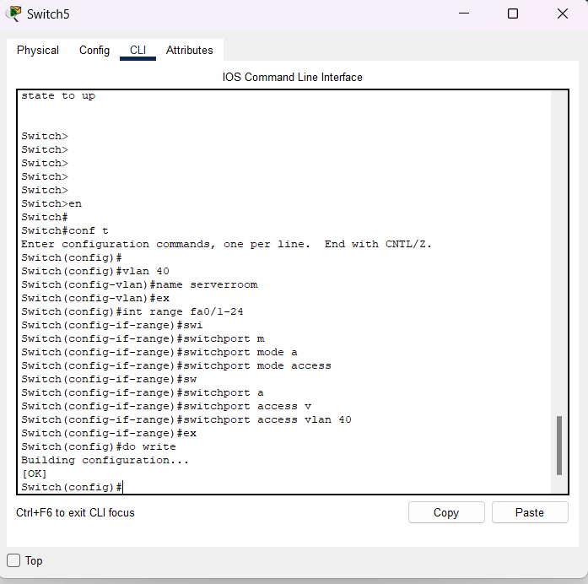

Switch 5

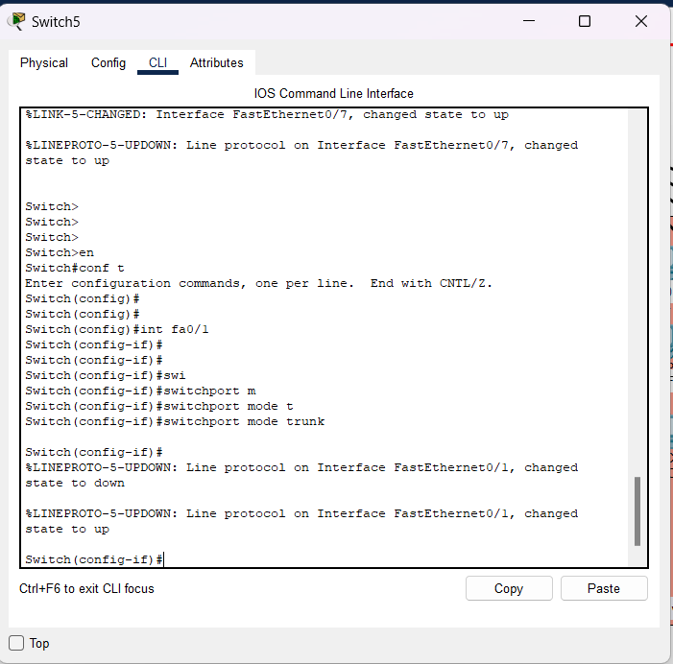

Switch 5 (1)

## D2: A maintenance schedule to support the networked system.

Figure : A maintenance schedule to support the networked system.

# LO4: Implement and diagnose networked systems

## P7: Implement a networked system based on a prepared design.

### 1. Network Design

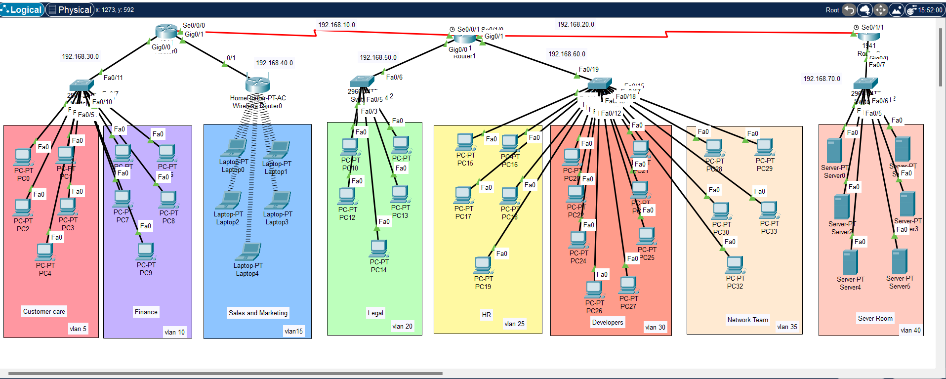

Figure : networked system based on a prepared design

The above screenshot can see the network design that user design for the Syntax Solution Company. In this Design there are 8 departments there are known as Custom care, Finance, Sales and Marketing, Legal, HR, Developers, Network team and Server room. And each depart has pc and there are servers in server room. To sales and Marketing Department user implement Wi-Fi for that department. And Each department has a Vlan.

### 2. IP Address Table



Figure : IP Address Table

## P8: Documenting and analysing test results against expected results.

|  |  |  |  |
| --- | --- | --- | --- |
| **Department** | **Expected results** | **Result** | **Test results** |
| Customer care | Packets: Sent = 4, Received = 4, Lost = 0 (0% loss), |  | Packets: Sent = 4, Received = 4, Lost = 0 (0% loss), |
| Finance | Packets: Sent = 4, Received = 4, Lost = 0 (0% loss) |  | Packets: Sent = 4, Received = 4, Lost = 0 (0% loss) |
| Sales and Marketing | Packets: Sent = 4, Received = 4, Lost = 0 (0% loss) |  | Packets: Sent = 4, Received = 4, Lost = 0 (0% loss) |
| Legal | Packets: Sent = 4, Received = 4, Lost = 0 (0% loss) |  | Packets: Sent = 4, Received = 4, Lost = 0 (0% loss) |
| HR | Packets: Sent = 4, Received = 4, Lost = 0 (0% loss), |  | Packets: Sent = 4, Received = 4, Lost = 0 (0% loss), |
| Developers | Packets: Sent = 4, Received = 4, Lost = 0 (0% loss) |  | Packets: Sent = 4, Received = 4, Lost = 0 (0% loss) |
| Network Team | Packets: Sent = 4, Received = 4, Lost = 0 (0% loss), |  | Packets: Sent = 4, Received = 4, Lost = 0 (0% loss), |

## M4: Potential enhancements for the networked systems.

A network should always update and developed for the future is very important.

However, in a network system how to potential enhancement for the network systems.

Now author explains how to enhancement a network system.

### 1.User should configure the network daily.

This means that configure should be always checked and it should be reconfigured

because it is not configured then it might be caused for the networking system.

Configure can’t be done by installing or updating a network it should reconfigure.

(Advanced Network Professionals, 2022)

### 2.Check for the viruses and system defectors.

When a network is not performing well it may be have a viruses such as malware

and that are caused many troubles for system so daily workers should check the

systems. (Advanced Network Professionals, 2022)

### 3.Upgrade and Update Firmware and Software

For each devise in a company or a system should update or upgrade the

firmware and software because may be the devices can slow when user do not

update it.is very important that when the softwares and firmware are updated it

is easy to work and control the system.

(Advanced Network Professionals, 2022)

### 4.Using Virtual Local Area Network

Using vlan make network easy because network can divide into categories. For

an example A company that has many departments can use vlan to divide the

network. (Advanced Network Professionals, 2022)

## D3: Critical reflection to evaluate own work and justify valid conclusions.

For the Company of syntax solutions author had to design a network design for this

company to work more efficiently. However, it is not easy to make a network design

because author should always update the new technologies that use nowadays. So

firstly, as a network consultant author make a blueprint network designed for get an

idea that how to make an efficient network system. Then as a network consultant

author thinks that what should the best topology for this company and how it works.

then author designed and make a efficient network designed for the company. Author

had more difficulties when this network system is designing but author managed to

complete it once at a time.

## Conclusion

In this project author faced many issues when designing the network system and when searching information about the topics. So firstly, author decide for this network project because it is very helpful when ever makes wrong thigs it will help to correct the mistakes. So, then author search more information and gathered them that might be important and finally then author designed the network design and completed the project. It was very interesting to do such a project. So, by this Project author learn new things and thank you.

# References

* Abba, I. V. (2022, april 21). *freecodecamp*. Retrieved from freecodecamp: https://www.freecodecamp.org/
* *Advanced Network Professionals*. (2022, June 30). Retrieved from Advanced Network Professionals: https://www.getanp.com/
* *GeeksforGeeks*. ( 2022, Octorber 18). Retrieved from GeeksforGeeks: https://www.geeksforgeeks.org/
* Team, I. E. (2021, january 13). *indeed*. Retrieved from indeed: https://www.indeed.com/
* *techopedia*. (2018, january 18). Retrieved from techopedia: https://www.techopedia.com/